

**Ferroelectricity in HfO2 enables**   
**nonvolatile data storage in 28 nm HKMG**

**Johannes Müller1, E. Yurchuk2, T. Schlösser3, J. Paul1, R. Hoffmann1, S. Müller2, D. Martin2, S. Slesazeck2, P. Polakowski1, J. Sundqvist1, M. Czernohorsky1,**   
**K. Seidel1, P. Kücher1, R. Boschke3, M. Trentzsch3, K. Gebauer3, U. Schröder2, T. Mikolajick2**

**1**  **2**

**3**

**Symposia on VLSI Technology and Circuits**

|  |  |
| --- | --- |
| **Outline**  • Introduction & Motivation  • Ferroelectricity in HfO2  • Adding nonvolatility to 28 nm HKMG (FeFET) • FeFET Device Performance  • Summary   |  | | --- | | **Slide 1** | |

|  |  |
| --- | --- |
| **Outline**  • **Introduction & Motivation**  • Ferroelectricity in HfO2  • Adding nonvolatility to 28 nm HKMG (FeFET) • FeFET Device Performance  • Summary   |  | | --- | | **Slide 2** | |

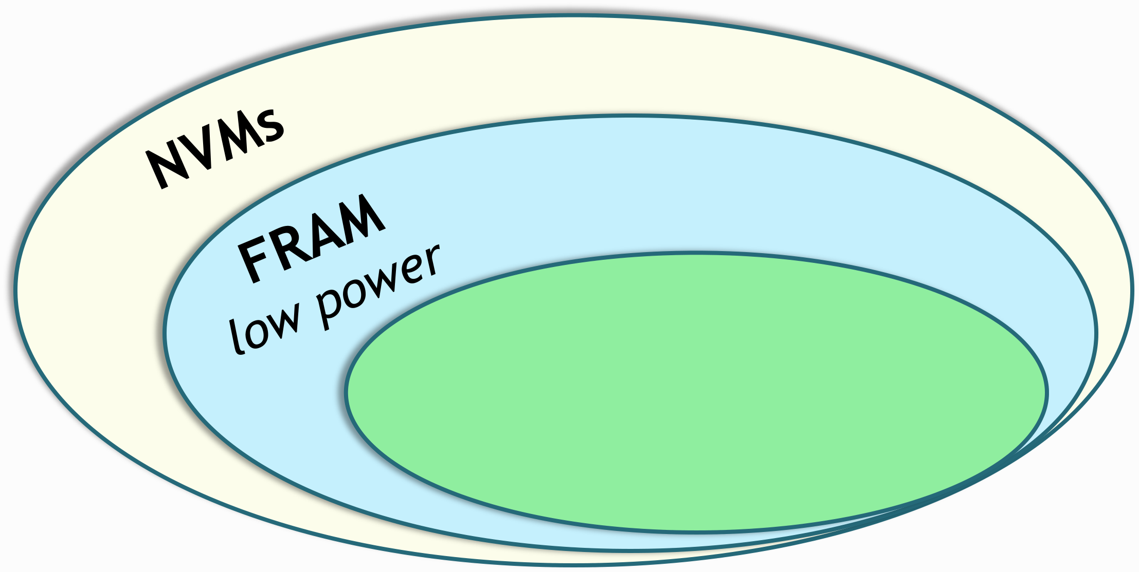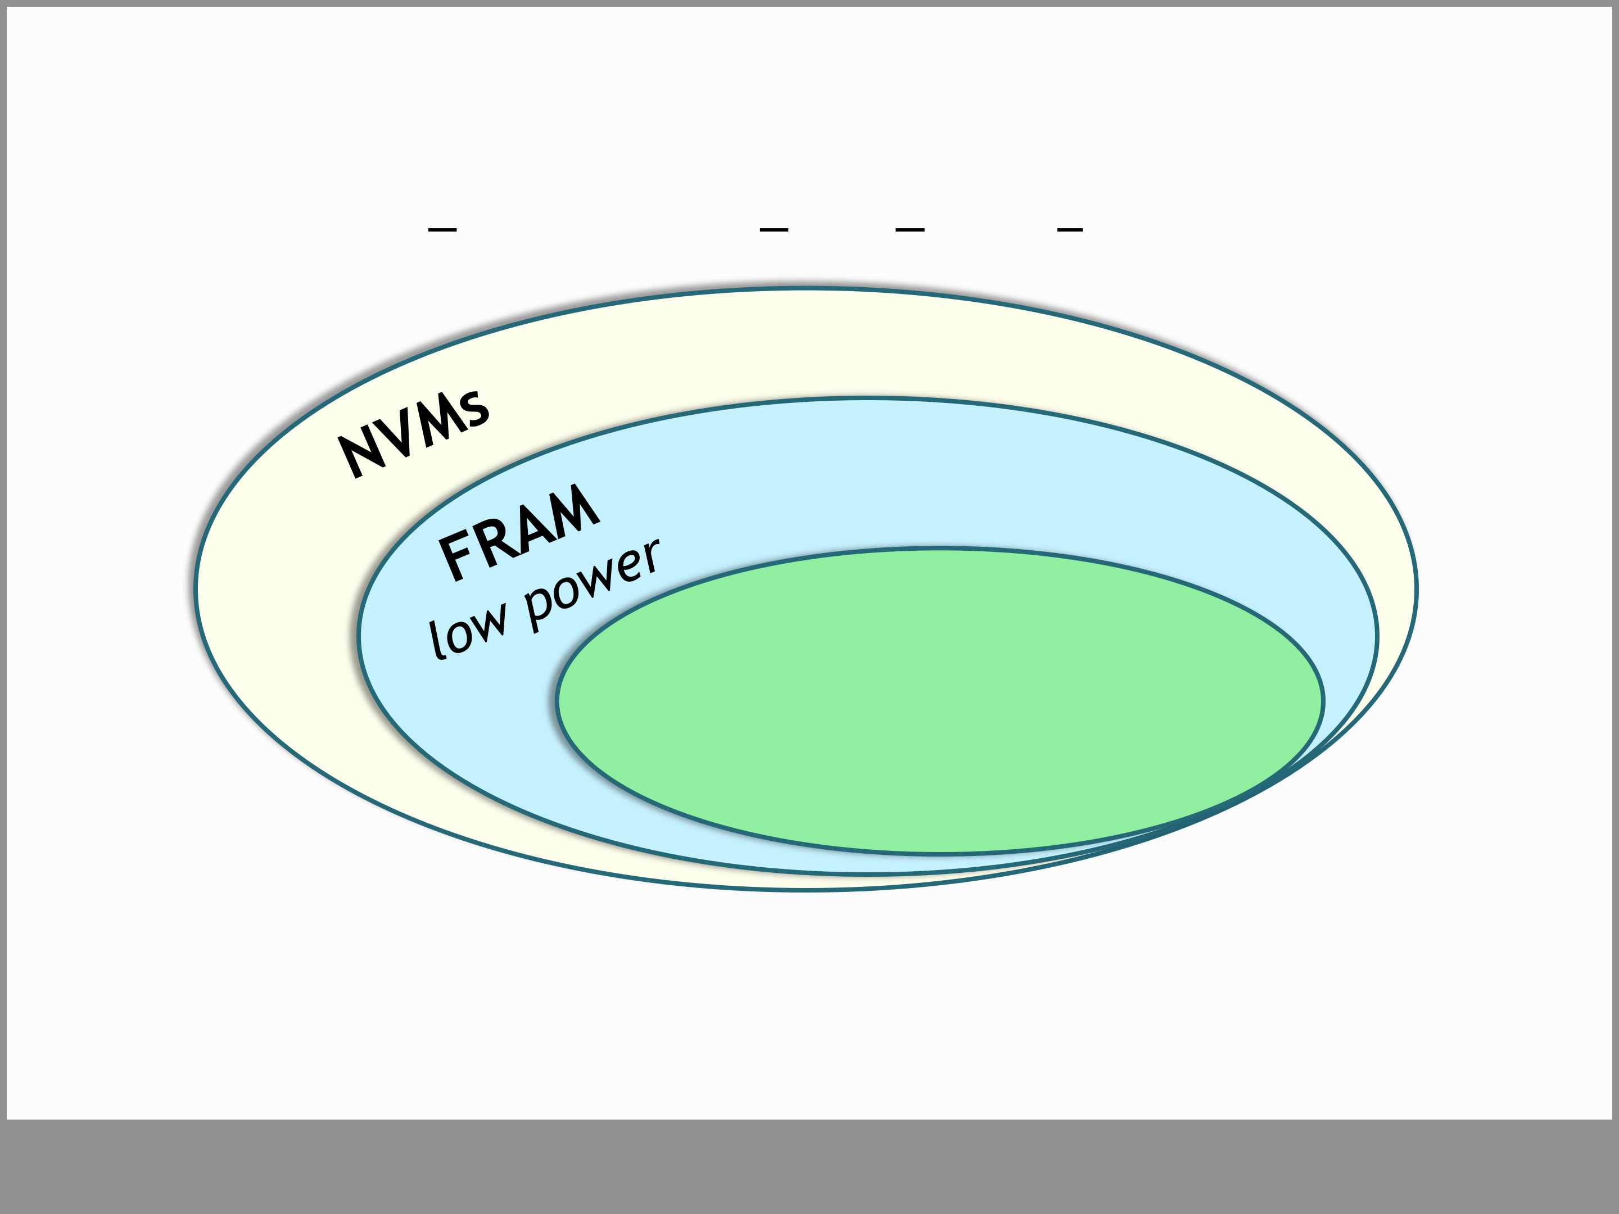

**The Benefit of 1T FRAM**

1T FRAM → Ferroelectric Field Effect Transistor (FeFET)

**1T FRAM**   
- *non-destructive read out*   
*- 1T memory cell*

• 50 years ago Moll and Tarui proposed the FeFET concept

• excellent R&D results since → but no commercialization yet

**Slide 3**

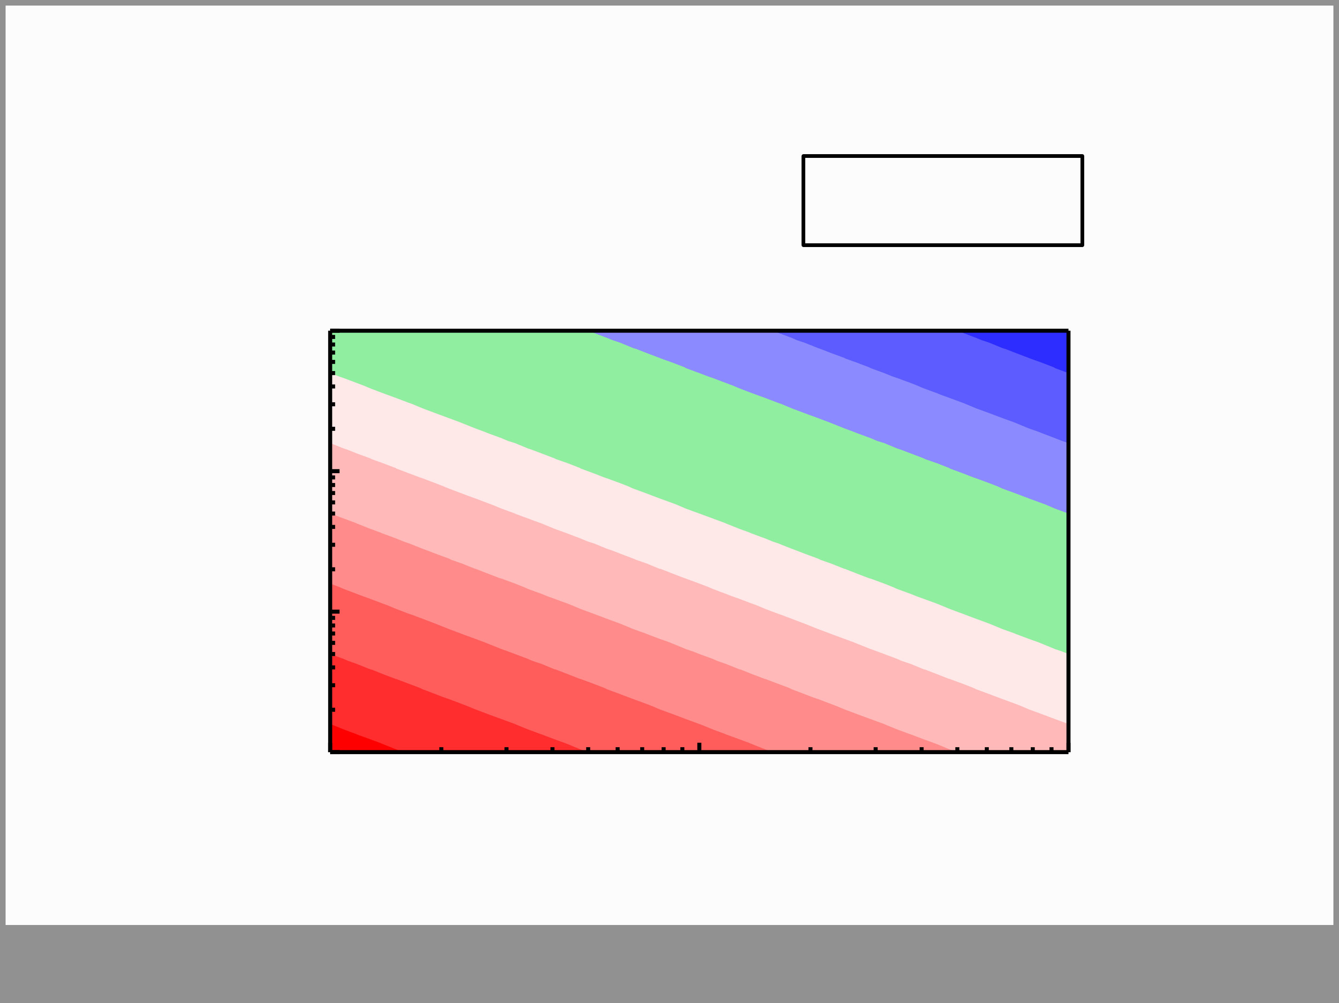

**Challenges of the FeFET** The Memory Window: **~2*Ec*dFE**

|  |  |  |  |
| --- | --- | --- | --- |
| **ferroelectric film thickness dFE** | 1 m | 100 kV/cm | 1 MV/cm |
| 100 nm |
| 10 nm |
| 1 nm |
| 10 kV/cm |

**coercive field Ec**�  
 **Slide 4**

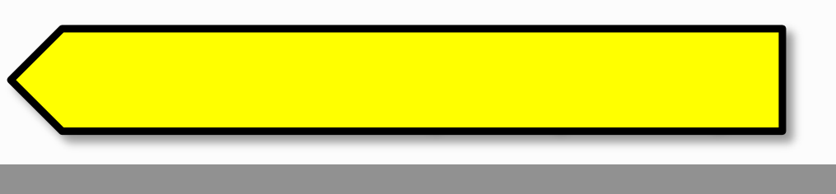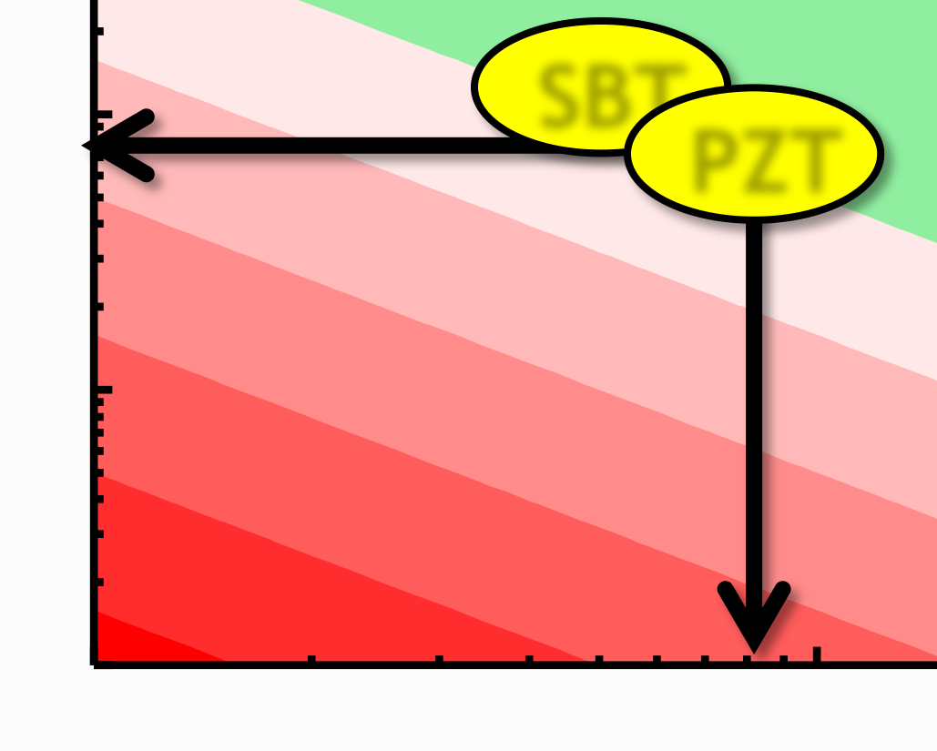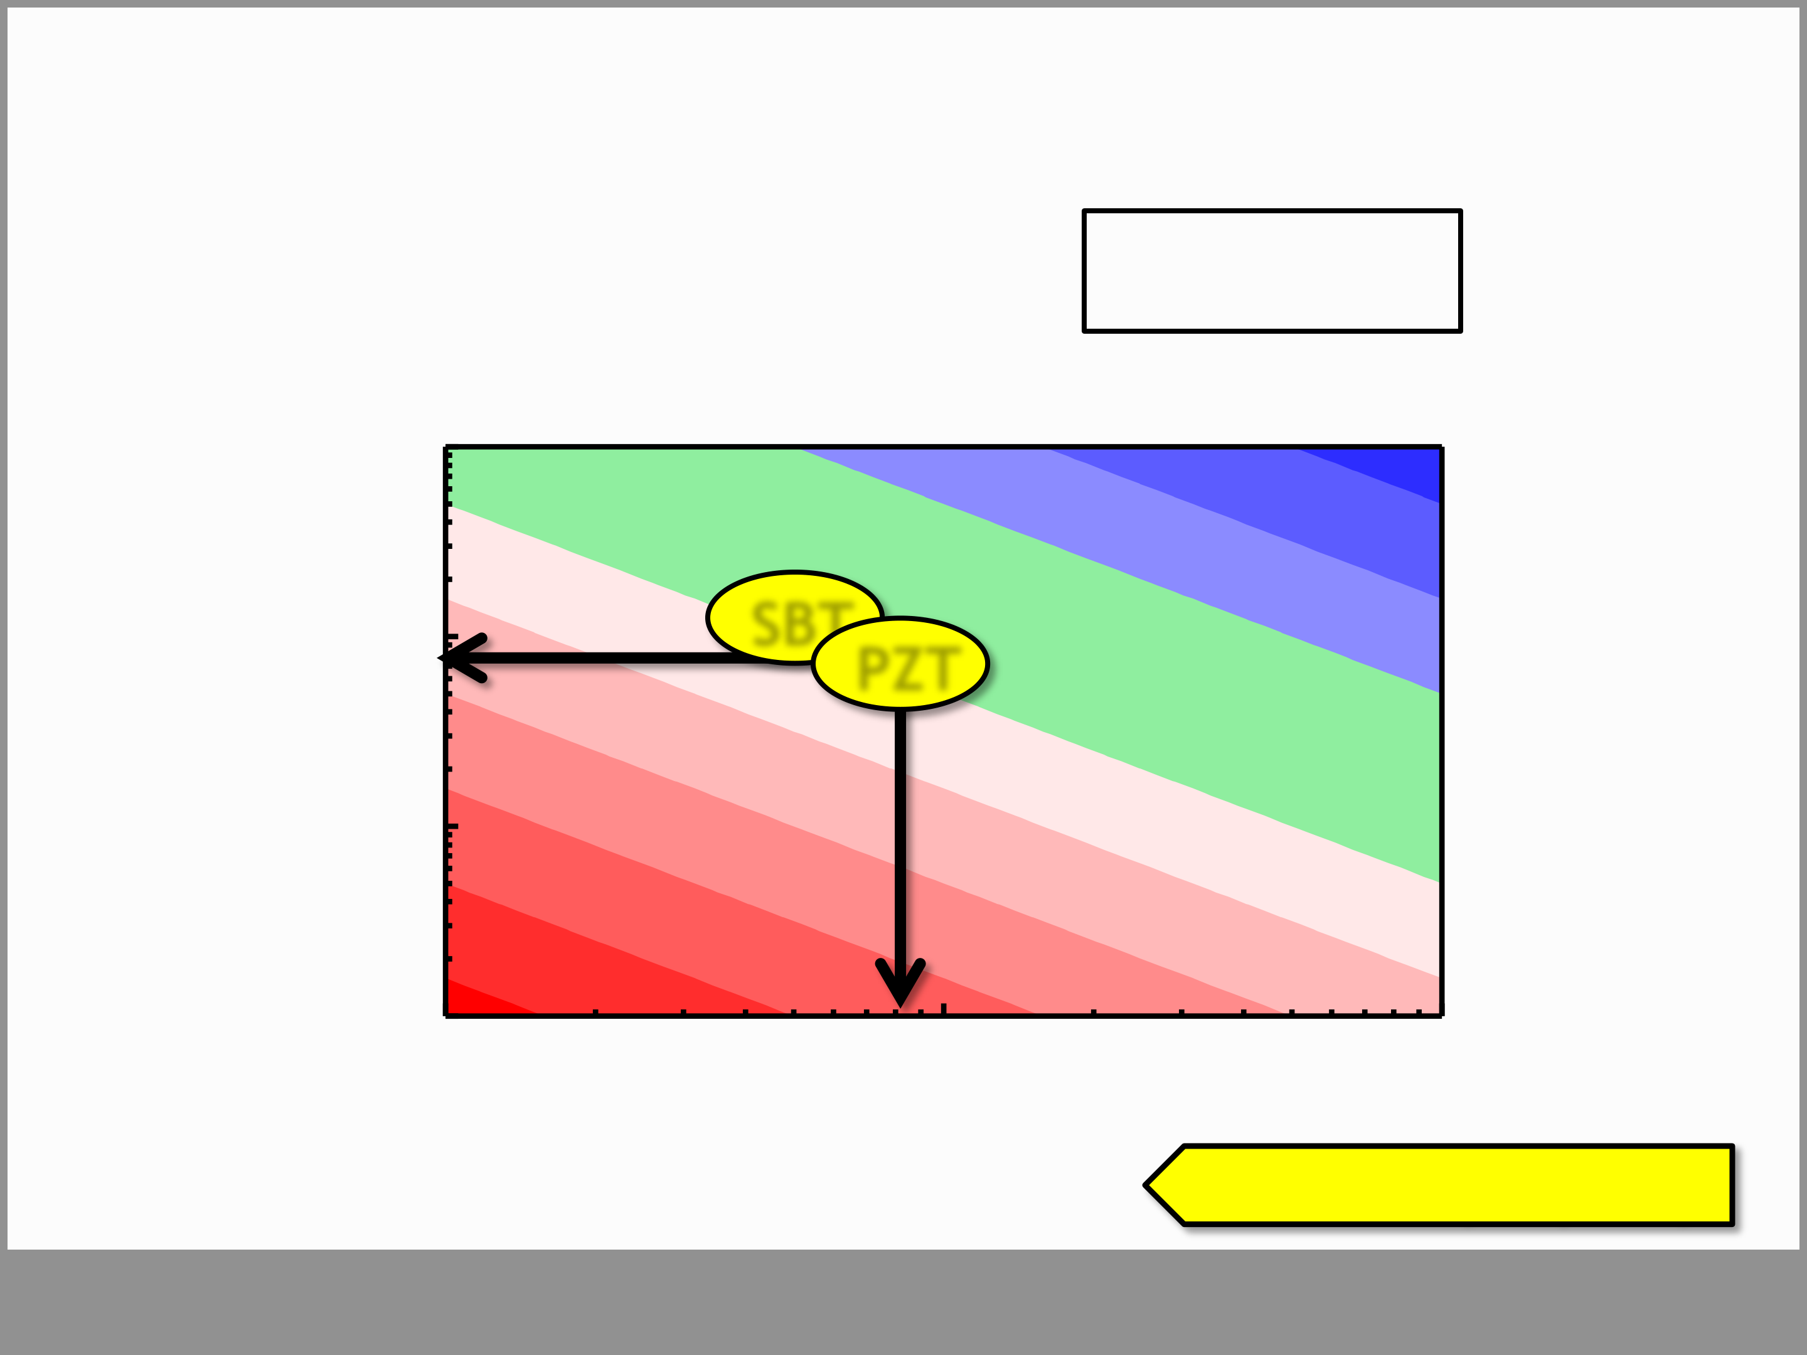

**Challenges of the FeFET** The Memory Window: **~2*Ec*dFE**

|  |  |
| --- | --- |
| **ferroelectric film thickness dFE** | **SBT PZT** |

**material property**   
 **Slide 5**

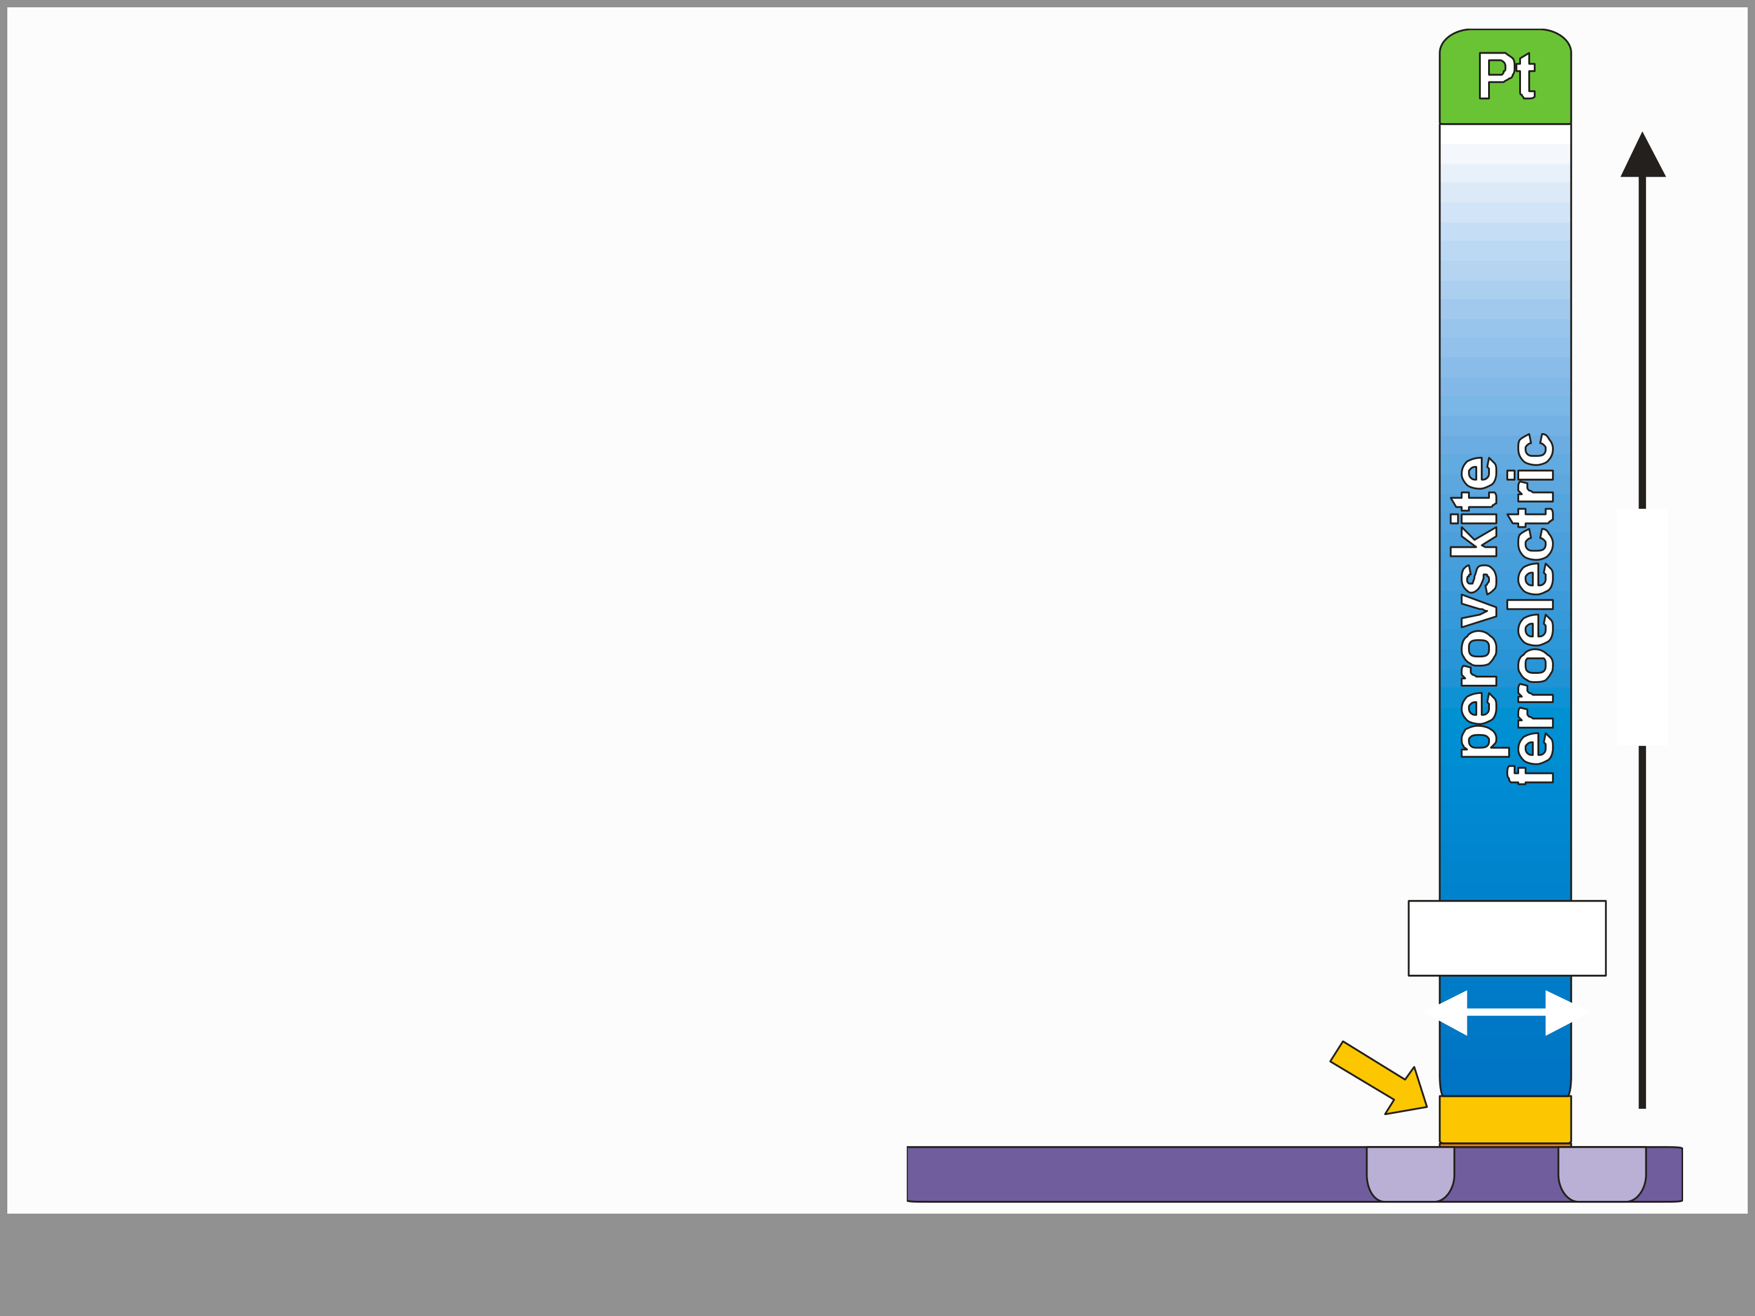

**Challenges of the FeFET**

• Memory Window limitations and “dead

layer” effects lead to scalability issues

|  |  |
| --- | --- |
| • PZT and SBT deposition & processing not widely spread in microelectr. manufacturing  • channel needs protection from ferroelectric  • non-benefical voltage divider due to high permittivity of perovskite ferroelectrics | **200 nm** |

→ retention issues

|  |  |  |
| --- | --- | --- |
| **“high-k”** **buffer layer** | **28 nm** | |
| **n +** | **n +** |

**Slide 6**

|  |  |
| --- | --- |
| **Outline**  • Introduction & Motivation  • **Ferroelectricity in HfO2**  • Adding nonvolatility to 28 nm HKMG (FeFET) • FeFET Device Performance  • Summary   |  | | --- | | **Slide 7** | |

|  |  |  |  |  |  |  |  |  |  |  |  |  |  |
| --- | --- | --- | --- | --- | --- | --- | --- | --- | --- | --- | --- | --- | --- |
| **Structural Origin of Ferroelectricity**  **HfO2 phases**   |  |  |  |  |  |  |  |  | | --- | --- | --- | --- | --- | --- | --- | --- | | **Cubic** (*Fm3m*) r ~ 28 |  | |  | | --- | |  | | **Temperature** | | |  | | --- | |  | | **Doping** | | | (*P42/nmc*) r ~ 35  **Tetragonal** | | | (*P21/c*) r ~ 20  **Monoclinic** | |  |  | | --- | | **Slide 8** | |

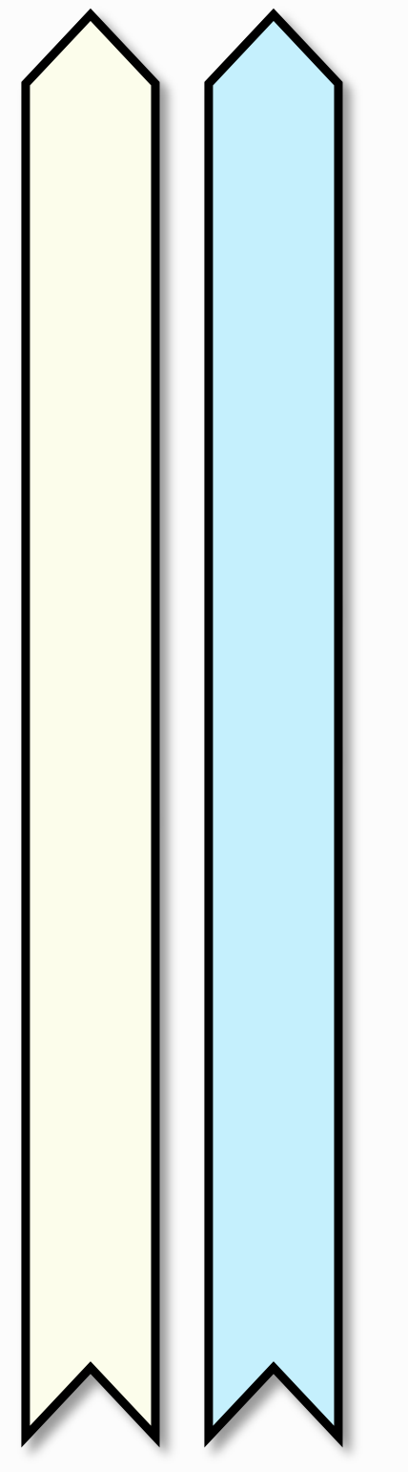

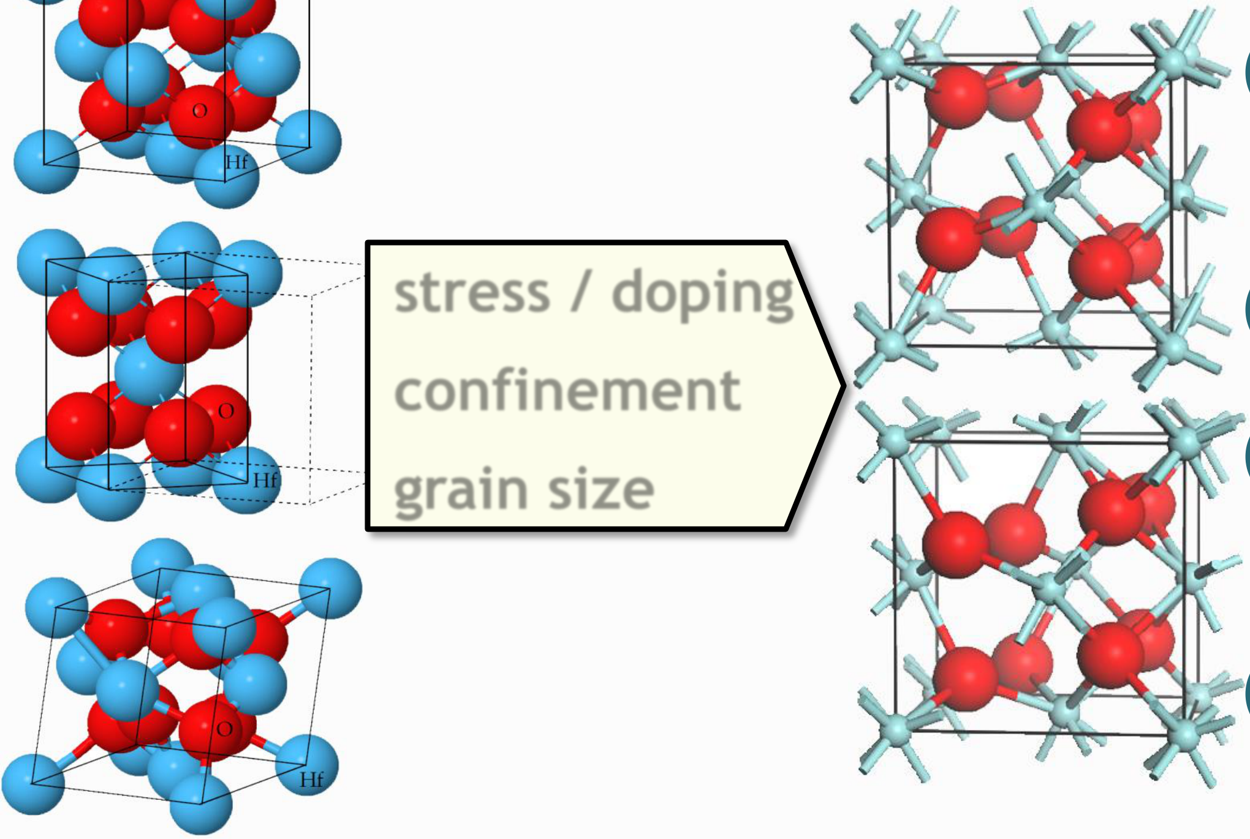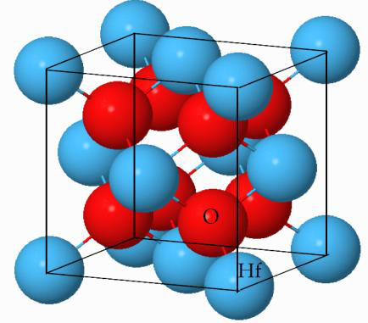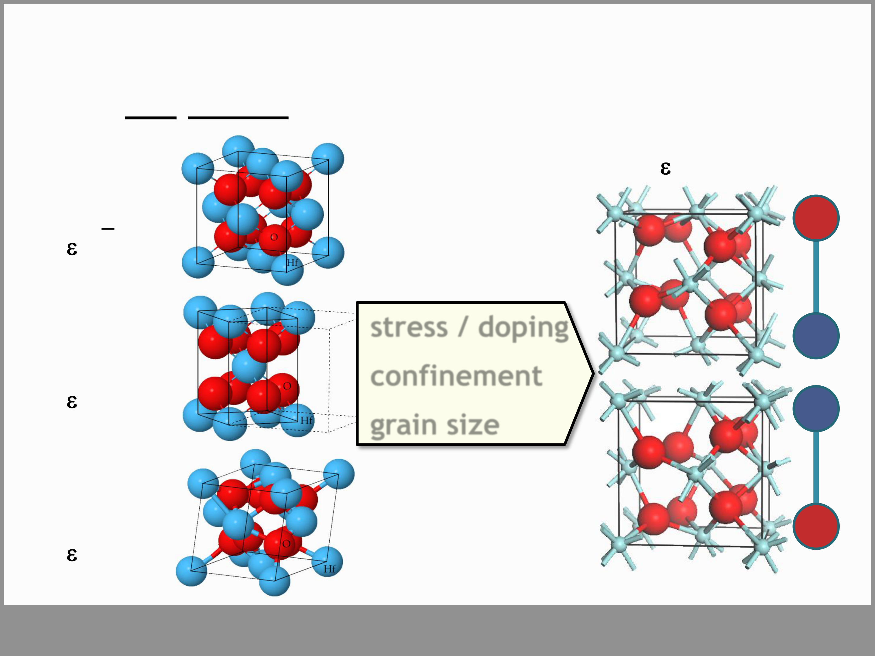

**Structural Origin of Ferroelectricity**

|  |  |  |  |
| --- | --- | --- | --- |
| **HfO2 phases** | **stress / doping** | **Orthorhombic** | **-** |
| *(Pbc21 )* r ~ 25 |
| **Cubic** |
| (*Fm3m*) |
| r ~ 28 |
| **Tetragonal** | **+** |
| (*P42/nmc*)  r ~ 35 | **confinement** |
| **+** |
| **grain size** |
| **Monoclinic** | **-** |
| (*P21/c*)  r ~ 20 |

**Slide 9**

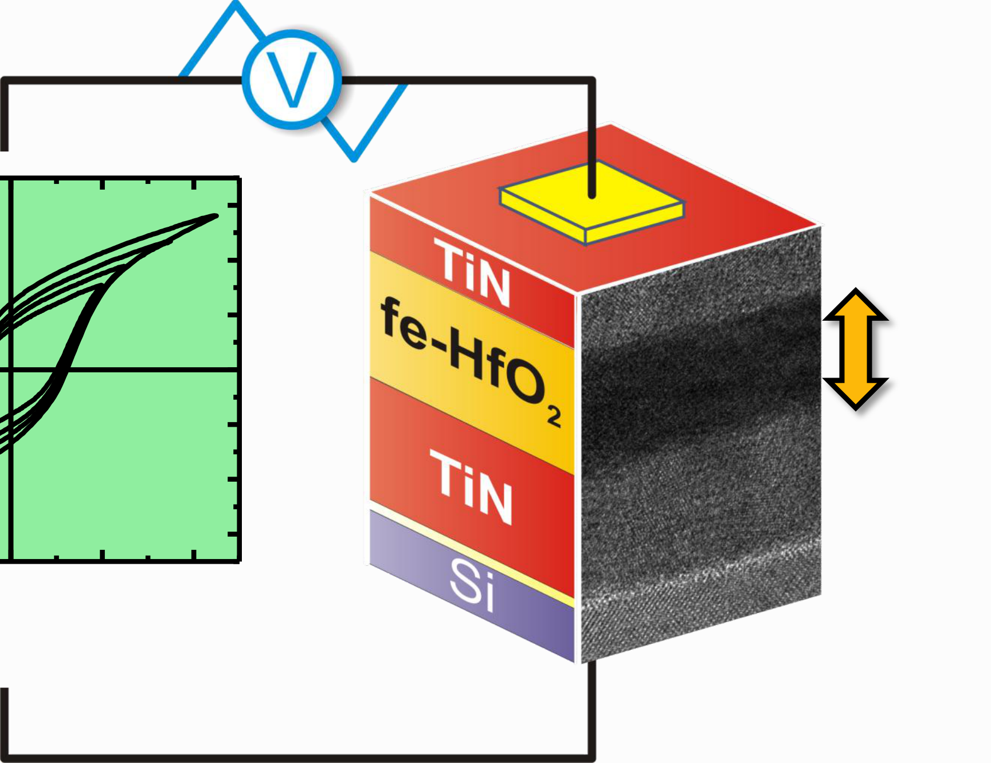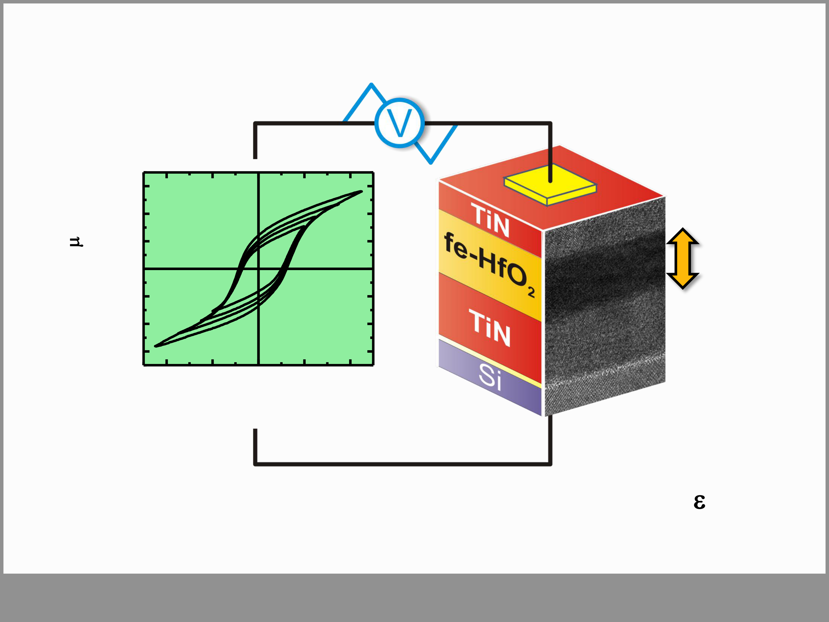

**MIM Polarization Hysteresis**

|  |  |  |  |  |  |  |  |
| --- | --- | --- | --- | --- | --- | --- | --- |
| **2)** | 30 | -4 | -2 | 0 | 2 | 4 | **10 nm** |
| **polarization (****C/cm** |
| 20 |
| 10 |
| 0 |
| -10 |
| -20 |
| -30 |

**bias (V)**

• fe-parameters: **Pr** ~8-30 µC/cm2 / **Ec** ~1 MV/cm / **r**~25

• structural & (piezo)electric data support true fe-phase

**Slide 10**

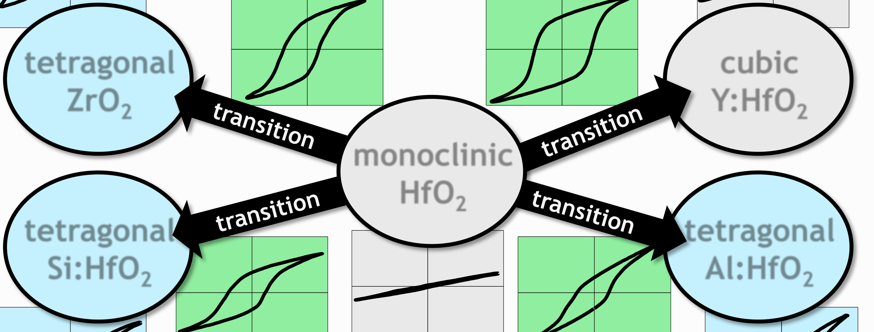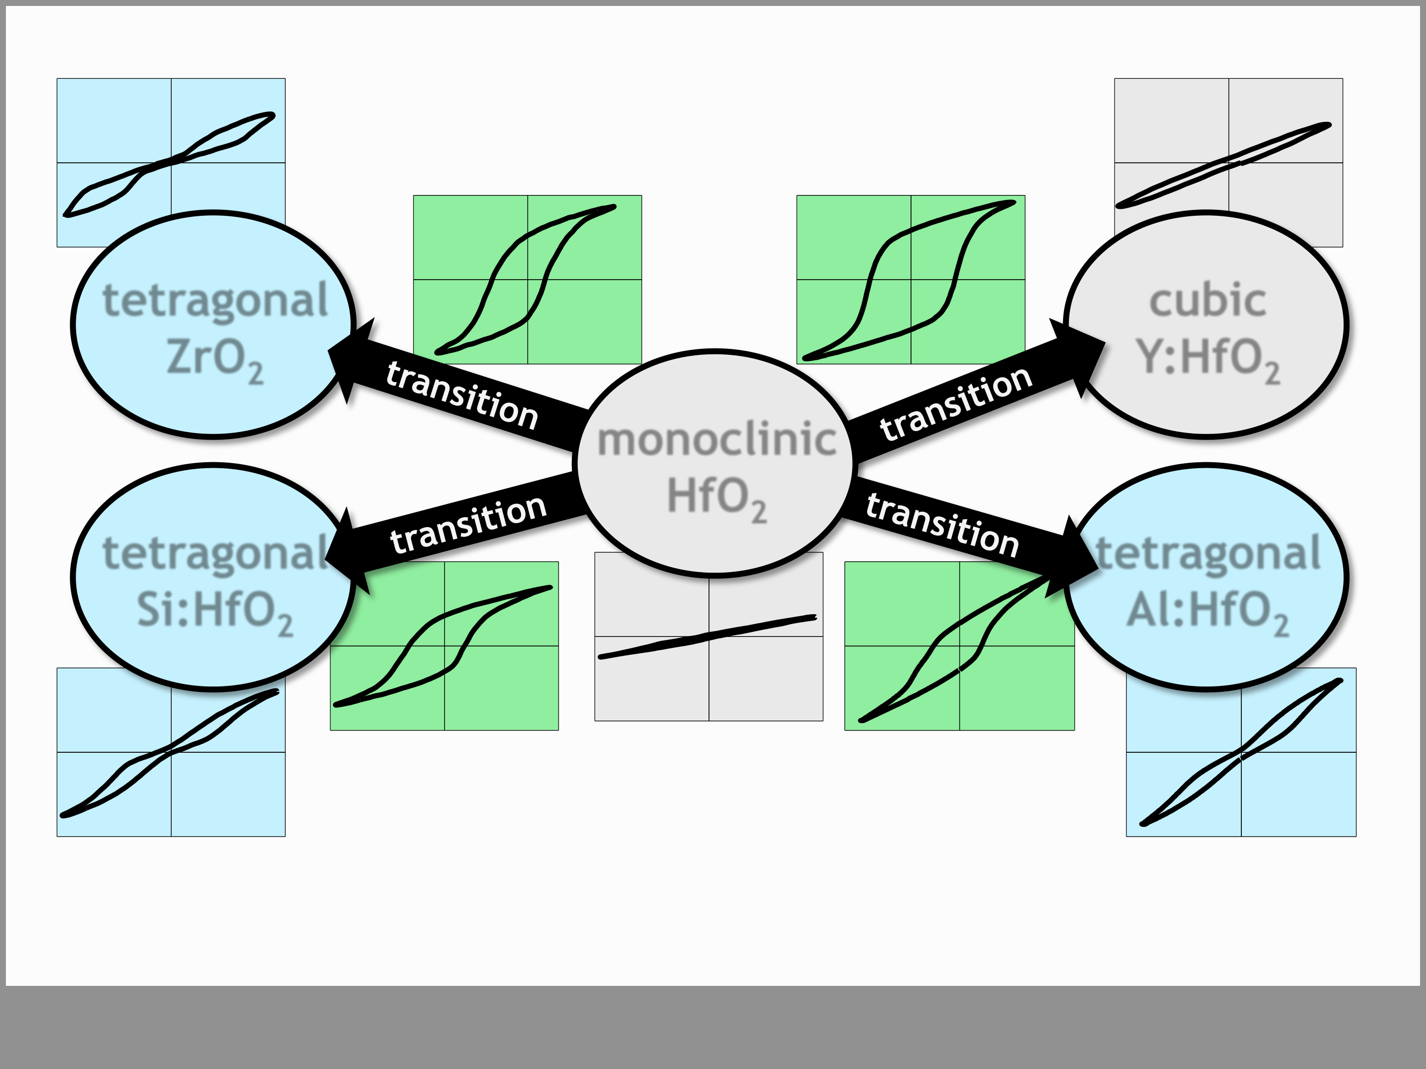

**Suitable Dopants**

**[1]**  **[2]**

**tetragonal**  **cubic**  **ZrO2**  **Y:HfO2**

**monoclinic**

|  |  |  |  |
| --- | --- | --- | --- |
| **[4]** | **P** | **HfO2** | **[3]**  **tetragonal** |
| **tetragonal** |
| **Si:HfO2** | **Al:HfO2** |

**V**

[1] *Müller, J. et al., APL (2011)*   
[2] *Müller, J. et al., JAP (2011)*   
[3] *Müller, S. et al., Adv. Funct. Mater. (2012)* [4] *Böscke, T.S. et al., APL (2011)*

**Slide 11**

|  |  |
| --- | --- |
| **Outline**  • Introduction & Motivation  • Ferroelectricity in HfO2  • **Adding nonvolatility to 28 nm HKMG (FeFET)** • FeFET Device Performance  • Summary   |  | | --- | | **Slide 12** | |

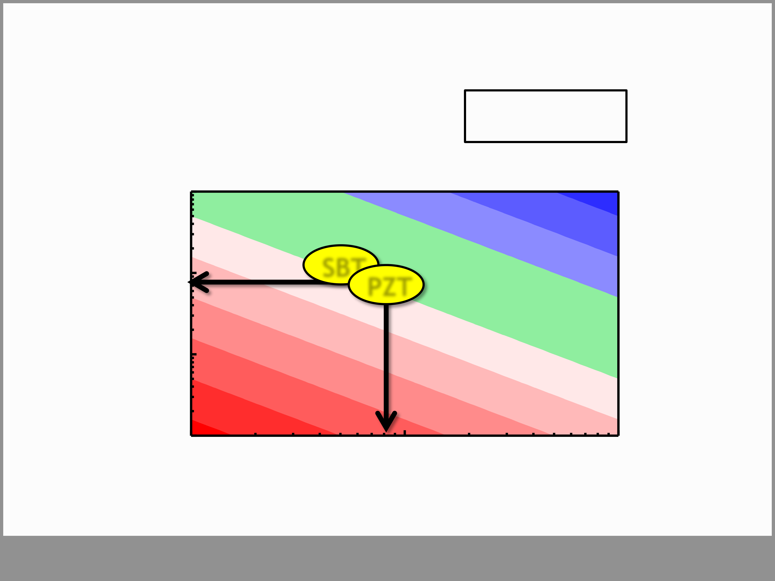

**fe-HfO2: CMOS-compatible and high Ec** The Memory Window: **~2*Ec*dFE**

|  |  |
| --- | --- |
| **ferroelectric film thickness dFE** | **SBT PZT** |

**Slide 13**

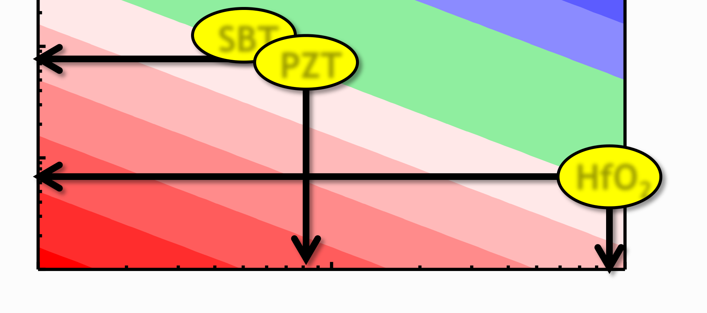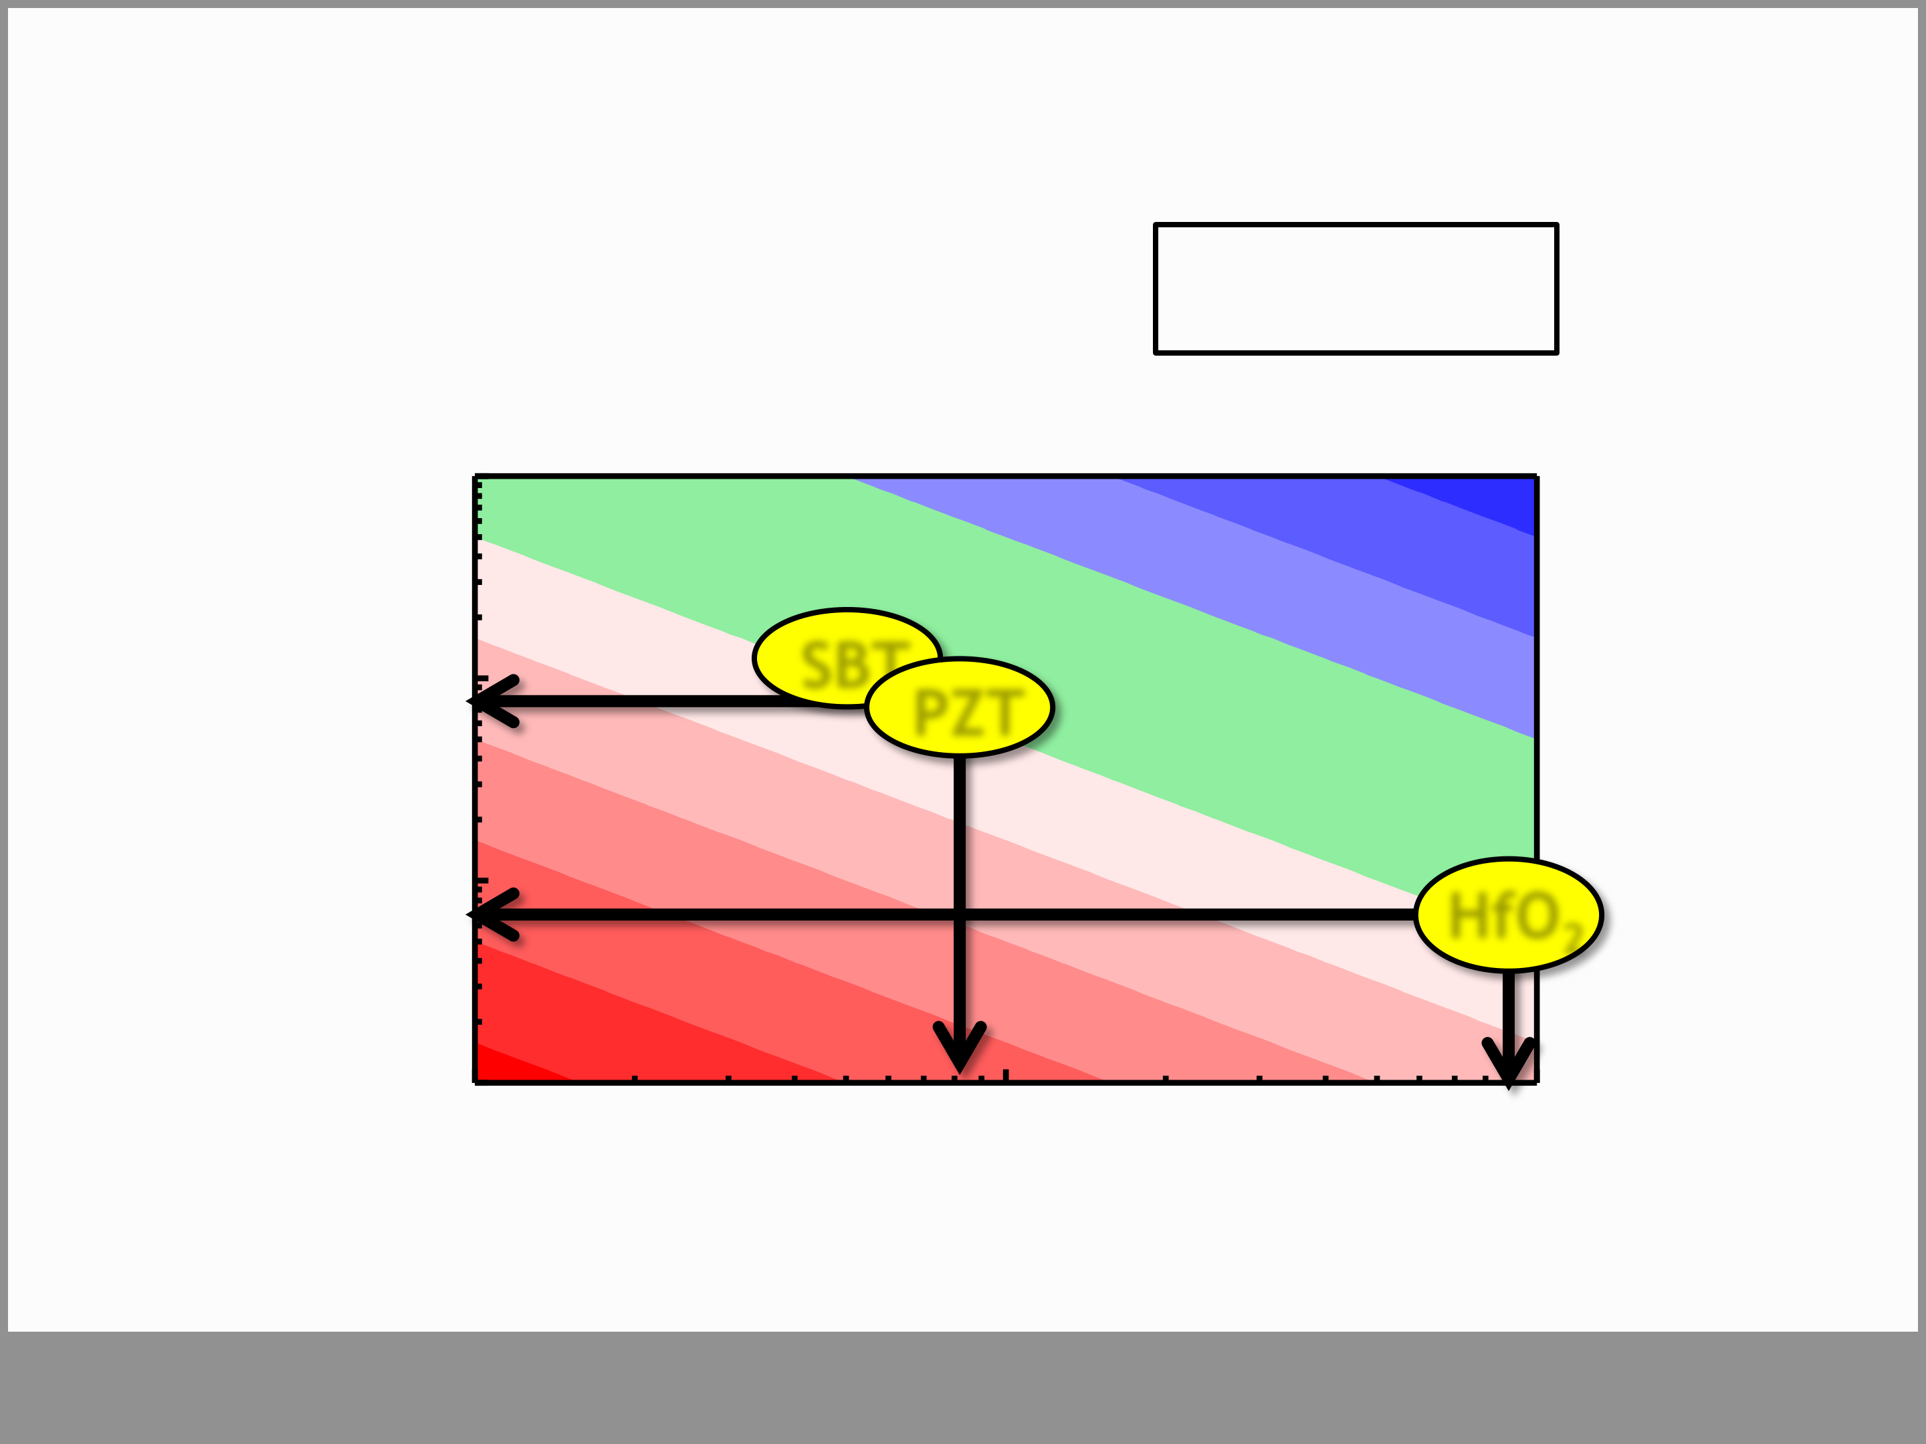

**fe-HfO2: CMOS-compatible and high Ec** The Memory Window: **~2*Ec*dFE**

|  |  |  |
| --- | --- | --- |
| **ferroelectric film thickness dFE** | **SBT PZT** | **HfO2** |

**Slide 14**

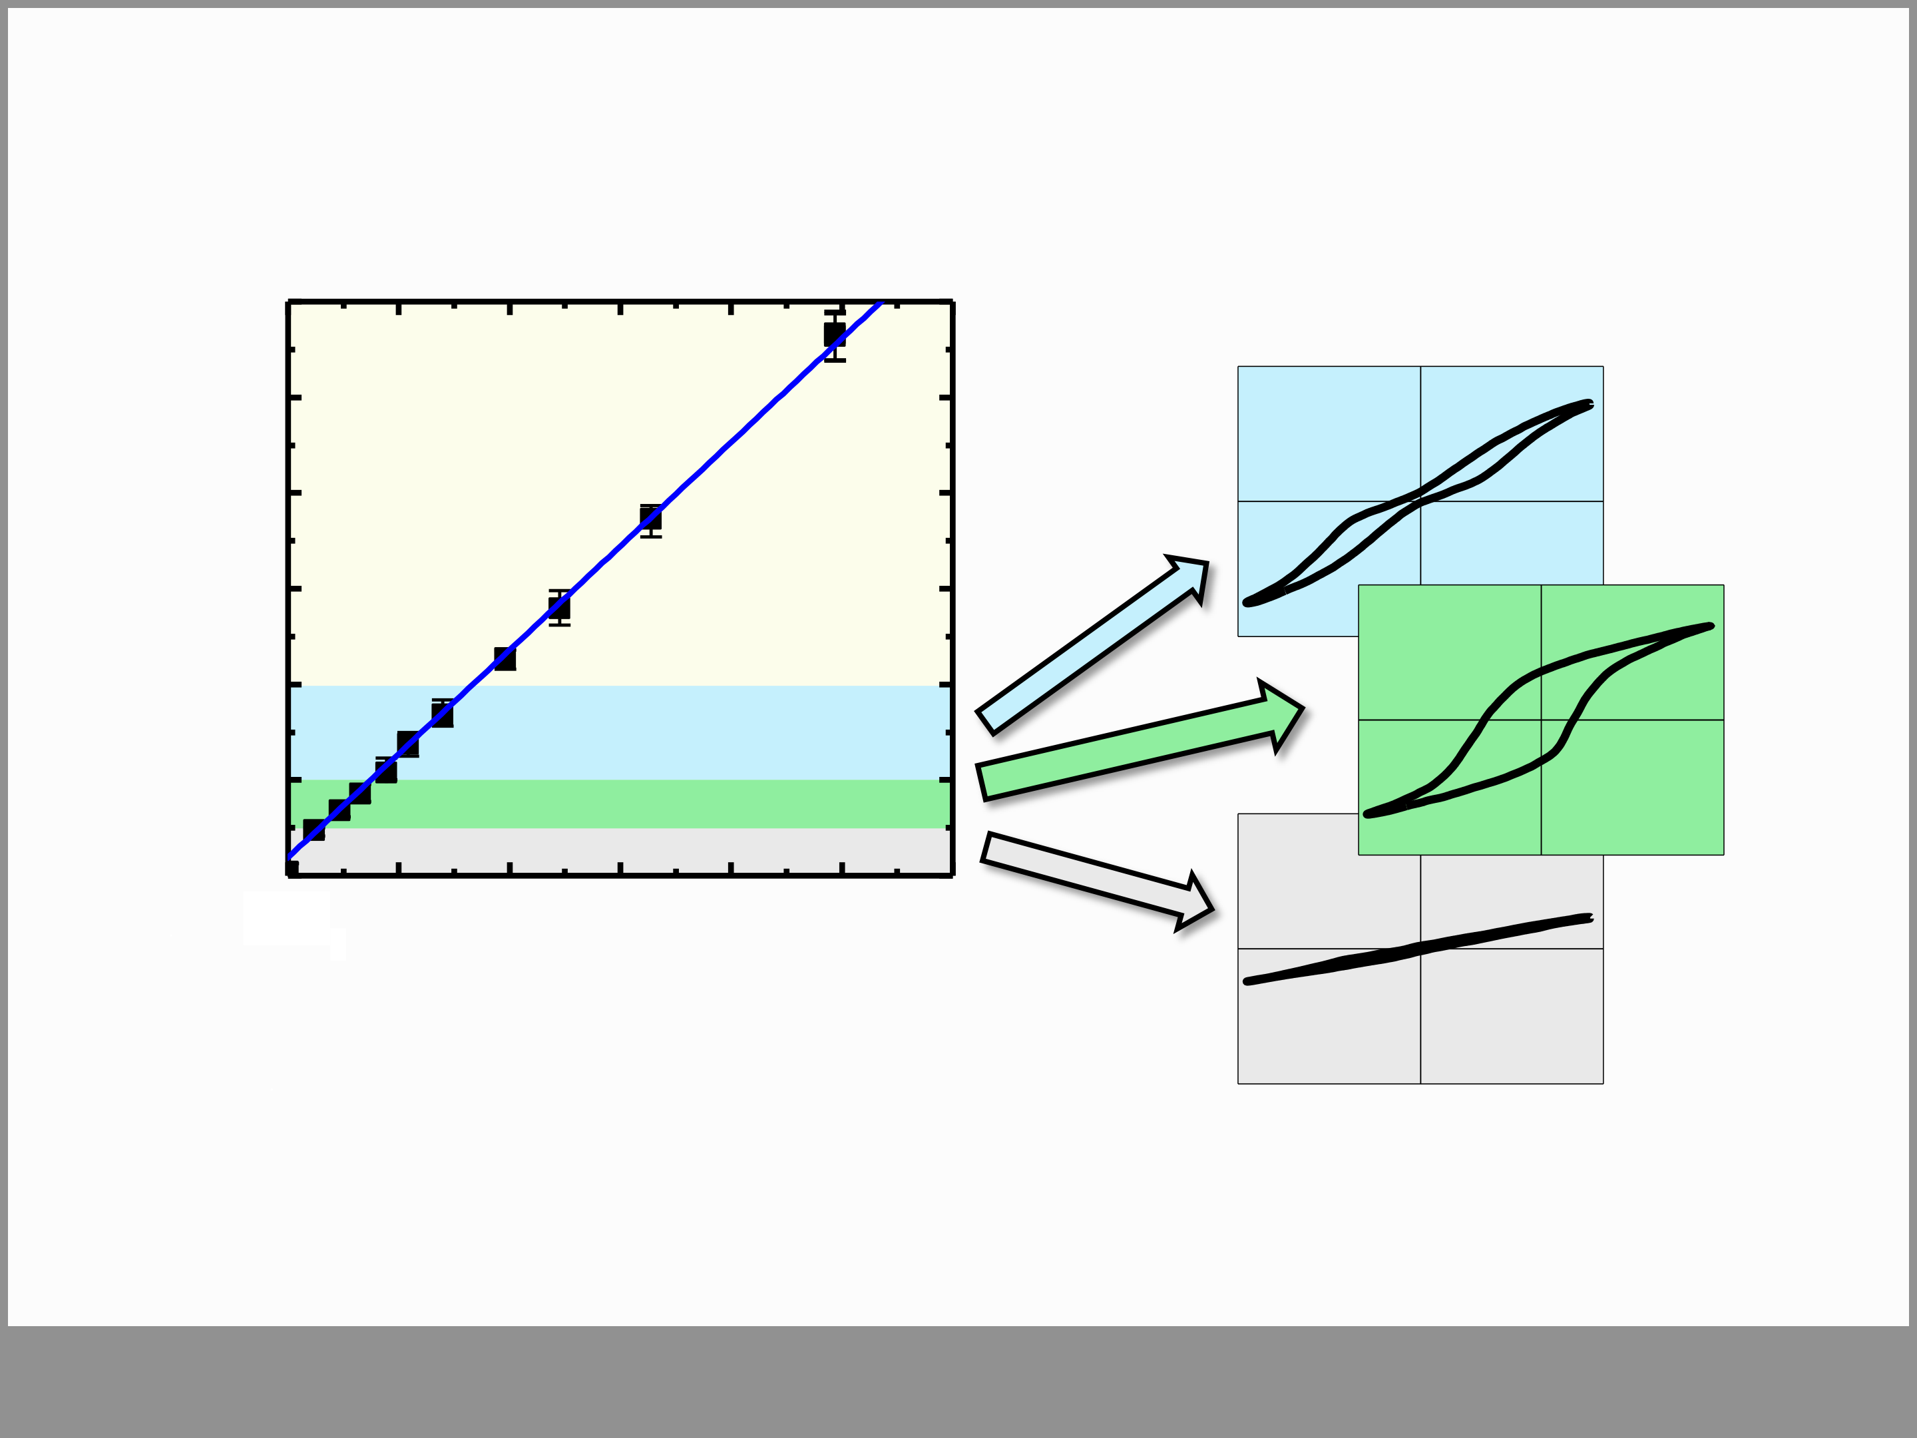

**ALD high-k deposition … little has to be changed**

30

|  |  |  |  |  |  |  |  |
| --- | --- | --- | --- | --- | --- | --- | --- |
| **SiO2 content (mol%)** | 25 | 0.1 | **stabilizing higher-k** | | | | |
| 20 |
| 15 |
| 10 |
| 5 |
| **fe-phase stabilization**  **lower-k phase** | | | | |
| 0  HfO2 |
| 0.2 | 0.3 | 0.4 | 0.5 | 0.6 |

**ALD: SiCl4/**(**SiCl4+HfCl4**)

• Si:HfO2 system is well known to microelectr. engineering

• for fe-HfO2 Si-content has to be precisley tuned (→ALD)

**Slide 15**

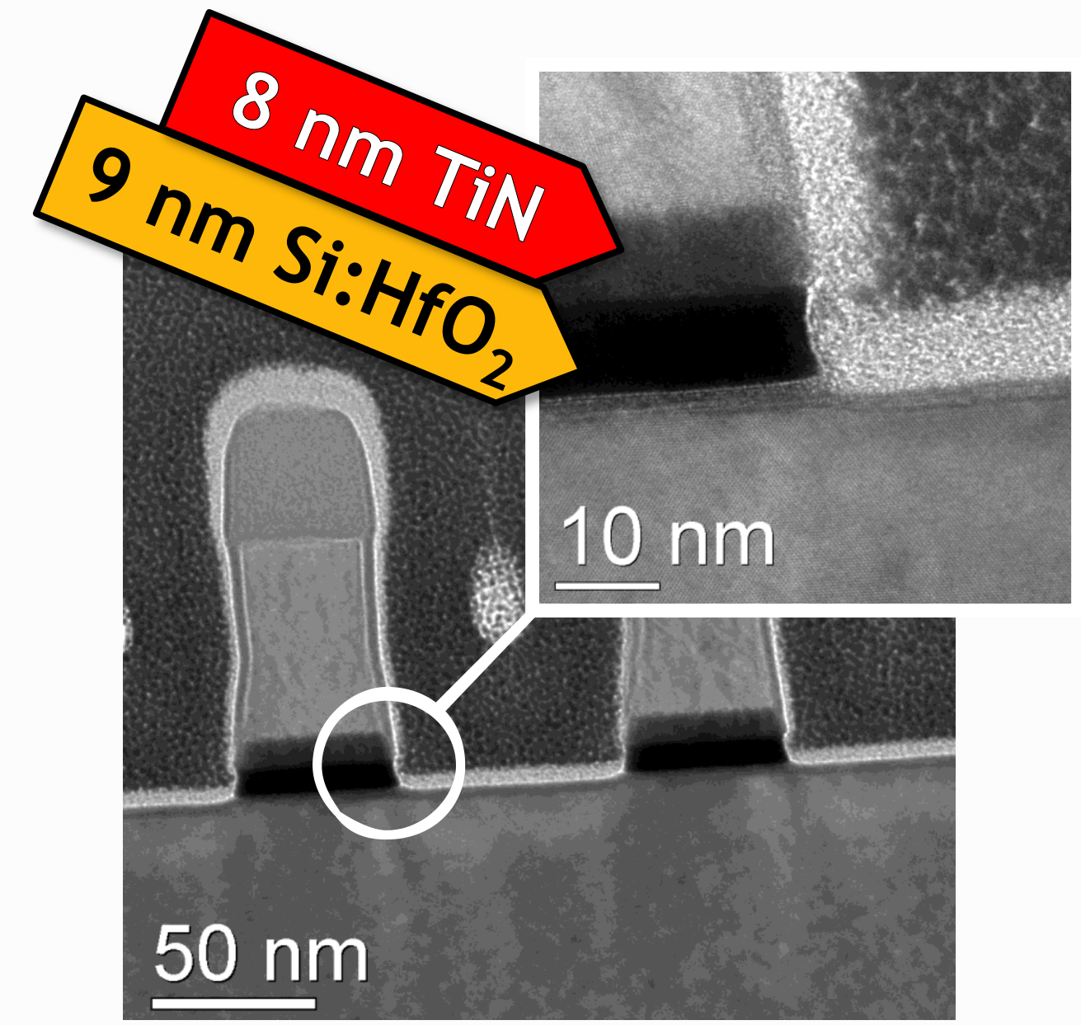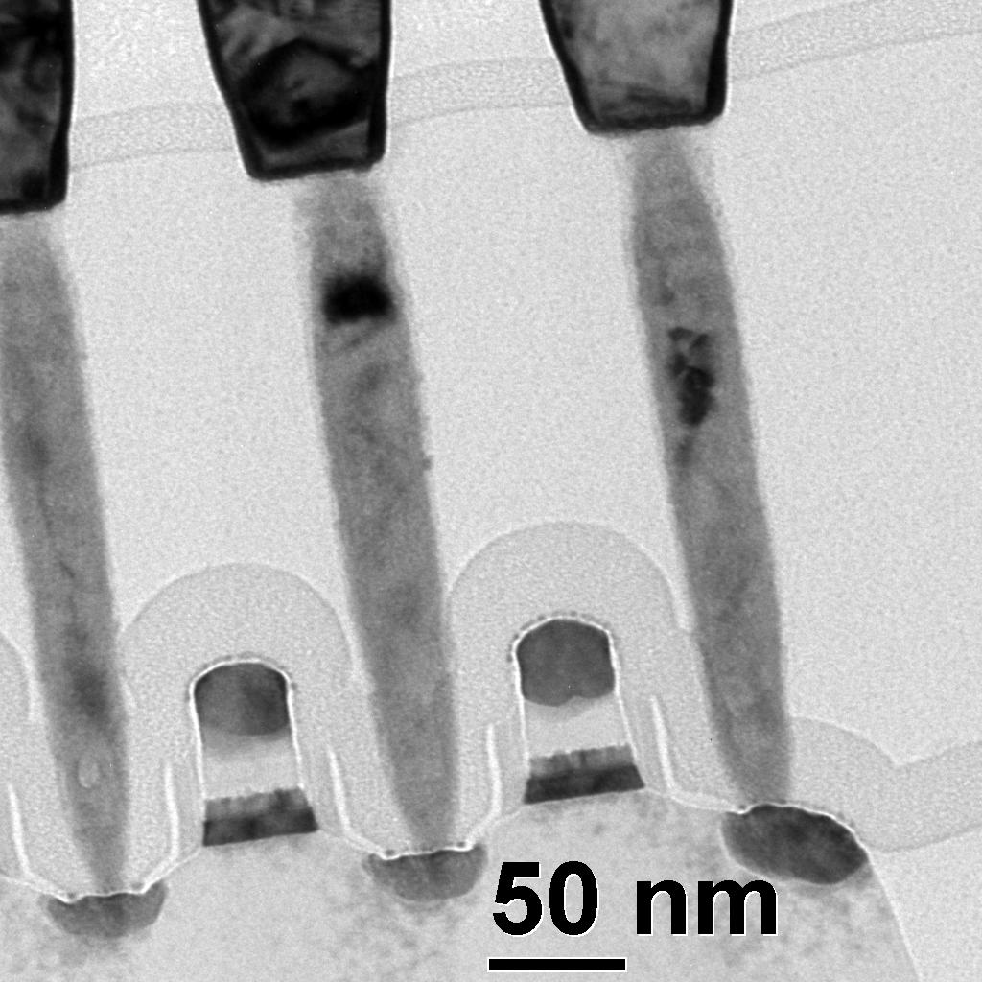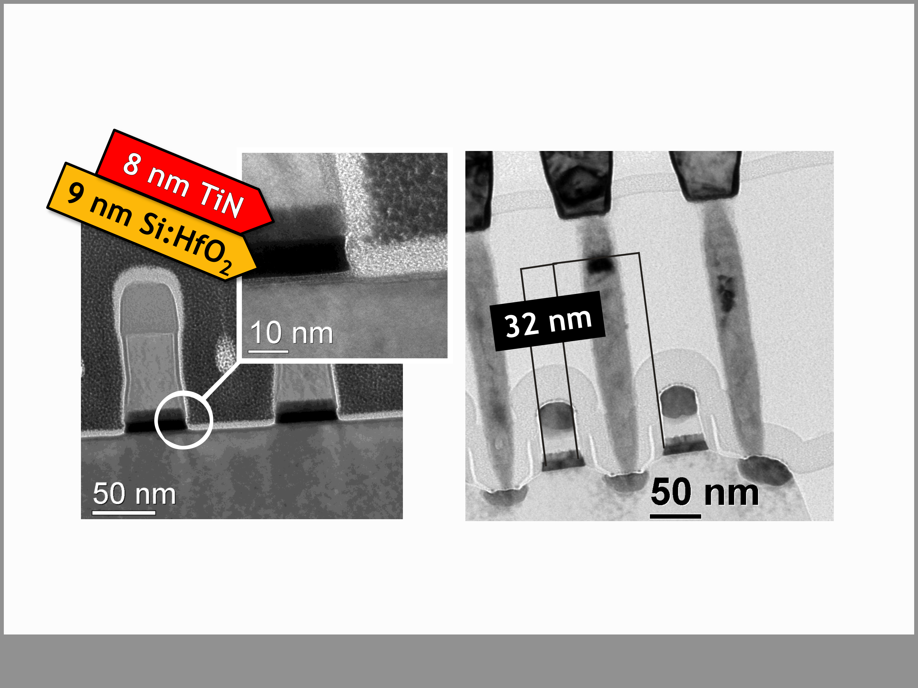

**Gate Etch**   
**…has to be adjusted**

**Cu**

**Si**

**W**

**Si**

• dry etch of thicker gate stack raises several issues

• „Hot Chuck“ yields reasonably steep sidewall angles

**Slide 16**

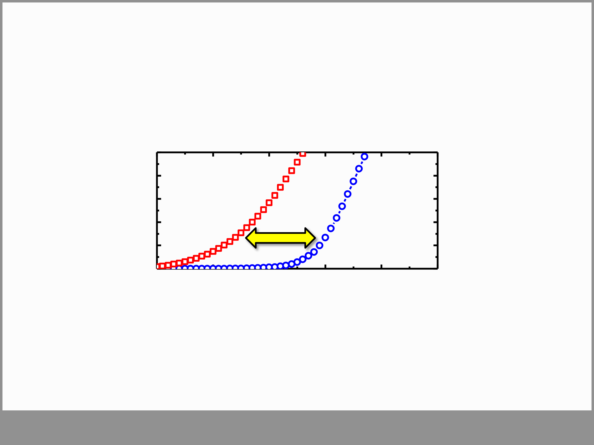

**Proof of Concept**

**L: 28 nm**

|  |  |  |  |  |  |  |
| --- | --- | --- | --- | --- | --- | --- |
| **drain current (a.u.)** | -1.0 | ERS +5V | **MW** | 0.5 | PGM-5V | 1.5 |
| -0.5 | 0.0 | 1.0 |

**gate bias (V)**

• counterclockwise Vth hysteresis indicates fe-switching

**Slide 17**

|  |  |
| --- | --- |
| **Outline**  • Introduction & Motivation  • Ferroelectricity in HfO2  • Adding nonvolatility to 28 nm HKMG (FeFET) • **FeFET Device Performance**  • Summary   |  | | --- | | **Slide 18** | |

|  |  |  |  |  |  |  |  |  |  |  |  |  |  |  |  |  |  |  |  |  |  |
| --- | --- | --- | --- | --- | --- | --- | --- | --- | --- | --- | --- | --- | --- | --- | --- | --- | --- | --- | --- | --- | --- |
| **Switching Speed and Voltage**  • fast switching only limited by RC time < 100 ns  • Both, **fe-switching & trapping** are **time & field** dependent   |  |  |  |  |  |  |  |  |  |  |  |  |  |  |  |  |  | | --- | --- | --- | --- | --- | --- | --- | --- | --- | --- | --- | --- | --- | --- | --- | --- | --- | | **pulse width**  1 ms   |  |  |  |  |  |  |  |  |  |  |  |  |  |  | | --- | --- | --- | --- | --- | --- | --- | --- | --- | --- | --- | --- | --- | --- | |  |  |  |  |  |  |  |  |  |  |  |  |  |  | | |  | |  | |  |  |  | |

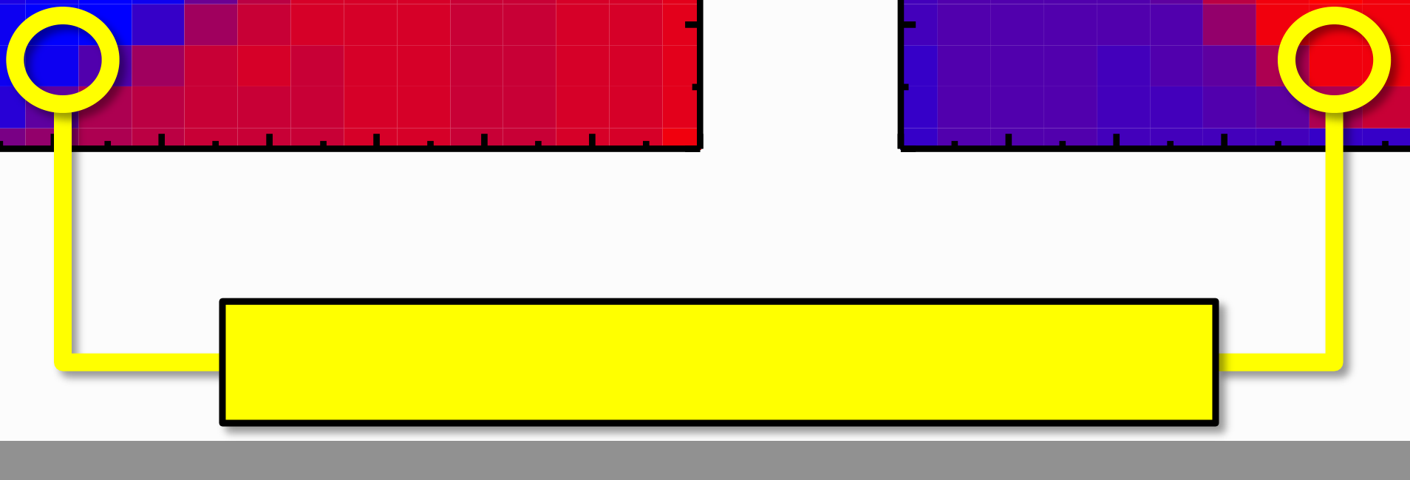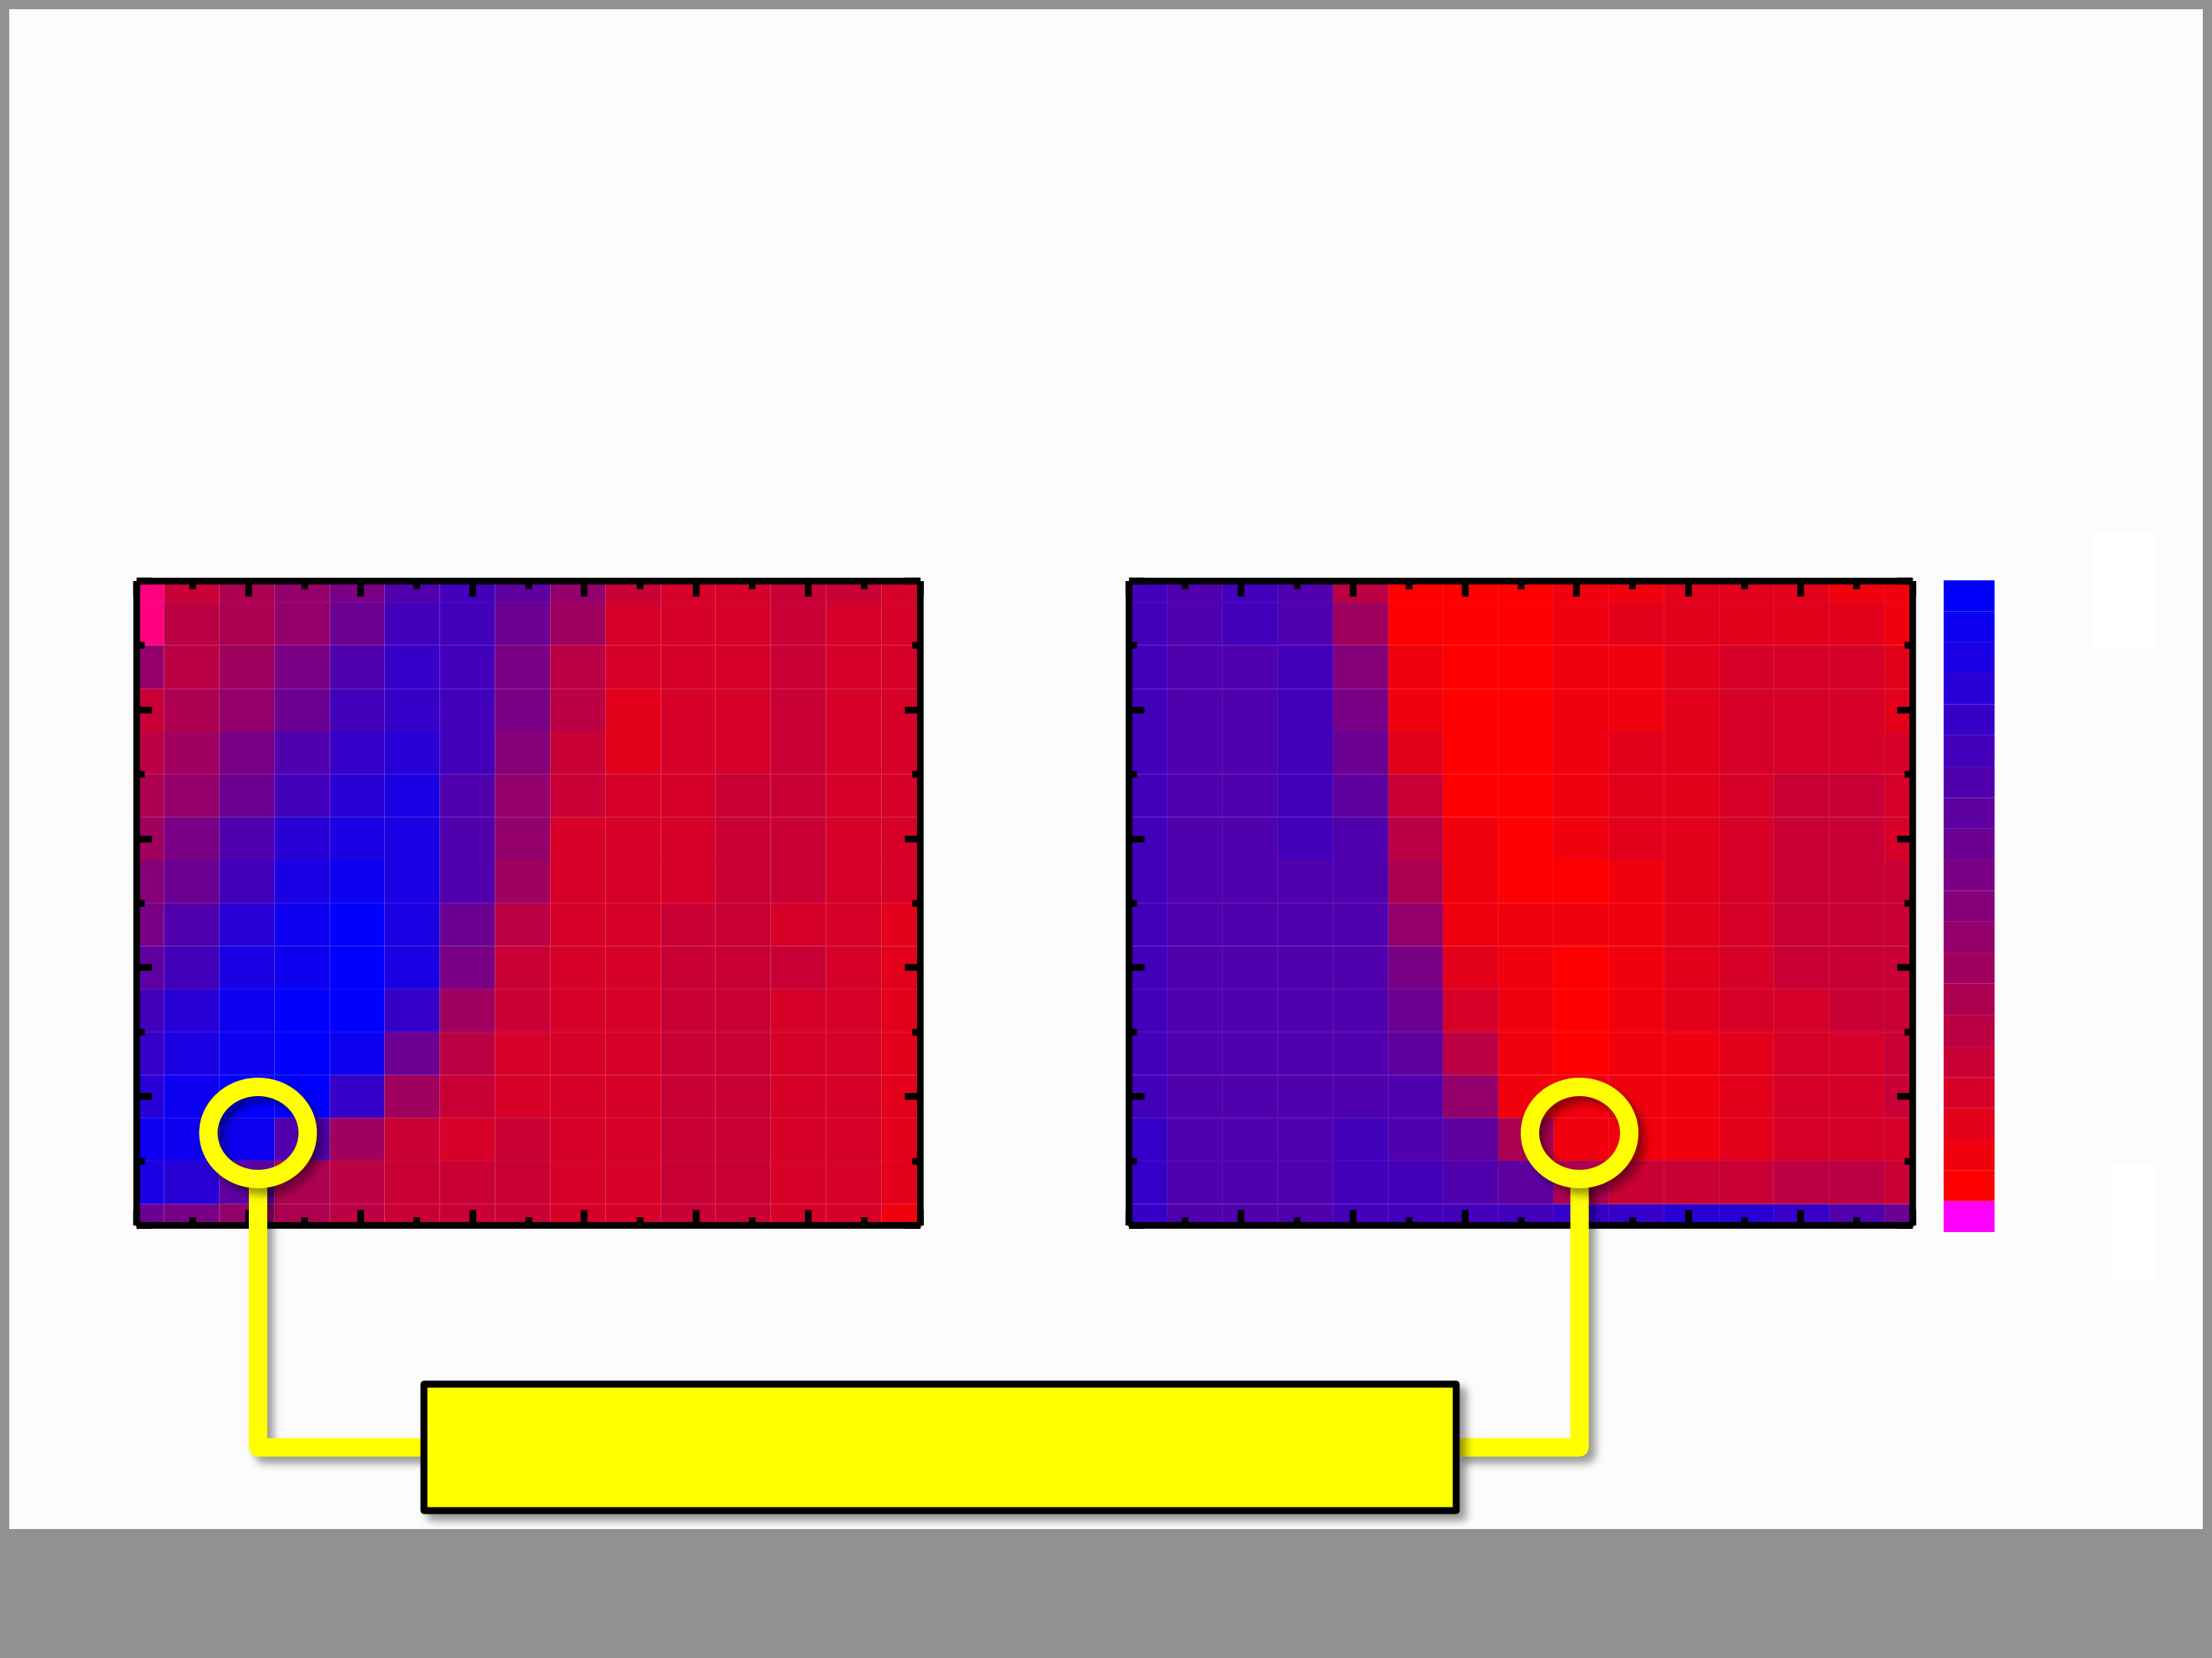

**Switching Speed and Voltage**   
• fast switching only limited by RC time < 100 ns   
• Both, **fe-switching & trapping** are **time & field** dependent

|  |  |  |  |  |  |  |  |  |  |  |  |  |  |  |  |  |  |
| --- | --- | --- | --- | --- | --- | --- | --- | --- | --- | --- | --- | --- | --- | --- | --- | --- | --- |
| -7 | -6 | -5 | -4 | -3 | -2 | -1 | **pulse width**  1 ms | | | 1 | 2 | 3 | 4 | 5 | 6 | 7 | 0.6000 |
| threshold voltage (V) |
| 100 s | | |
| 10 s | | |
| 1 s | | |
| 100 ns | | |
| 0 | 10 ns | 0 | -0.3000 |
| < -0.3 |
| **program level (V)** | | | | **erase level (V)** | | |

**Memory Window ~ 0.9 V**   
 **Slide 20**

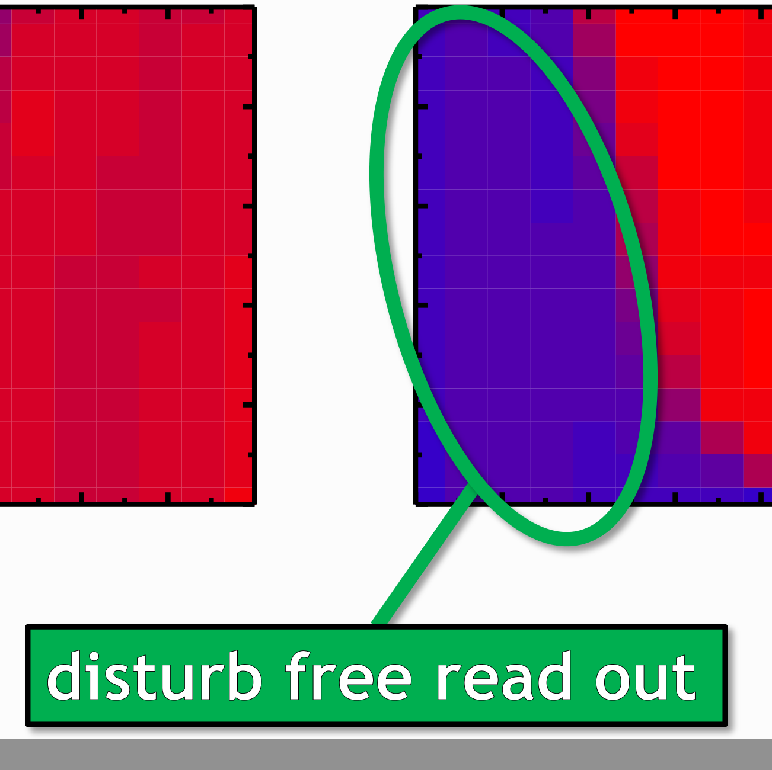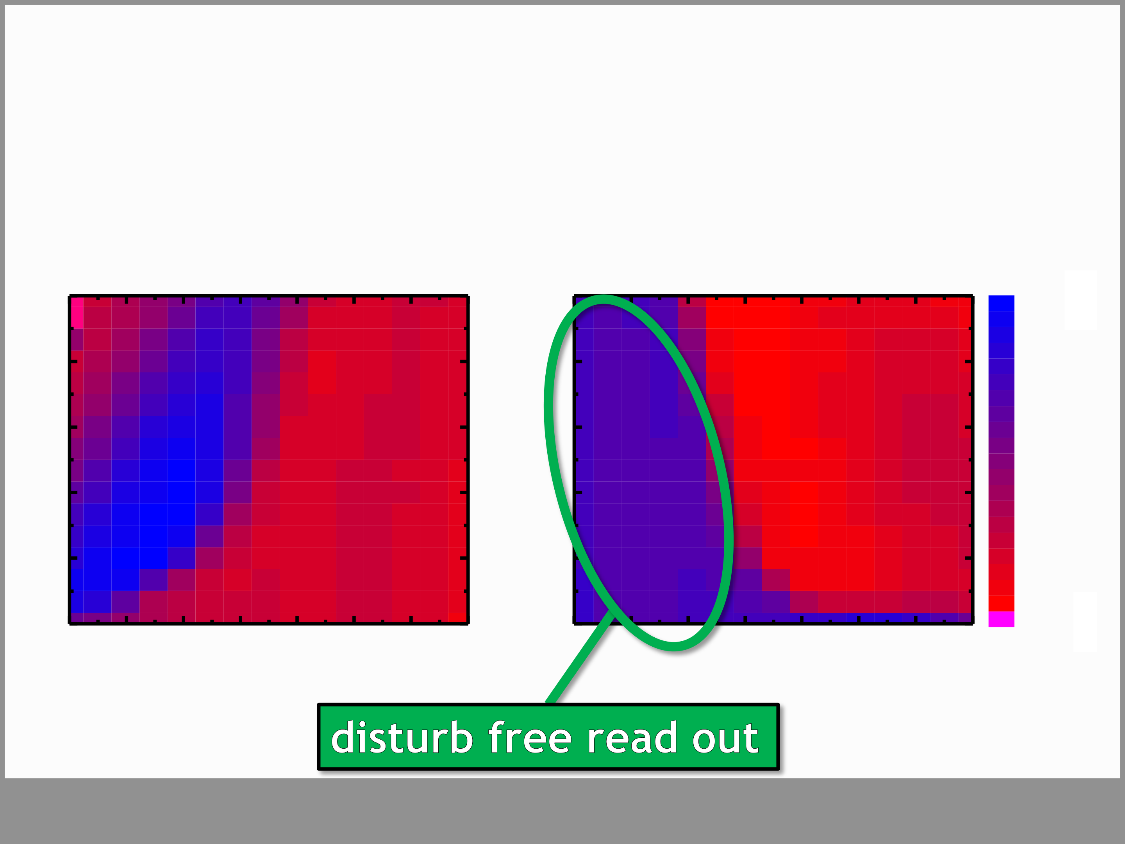

**Switching Speed and Voltage**   
• fast switching only limited by RC time < 100 ns   
• Both, **fe-switching & trapping** are **time & field** dependent

threshold voltage (V)

**Slide 21**

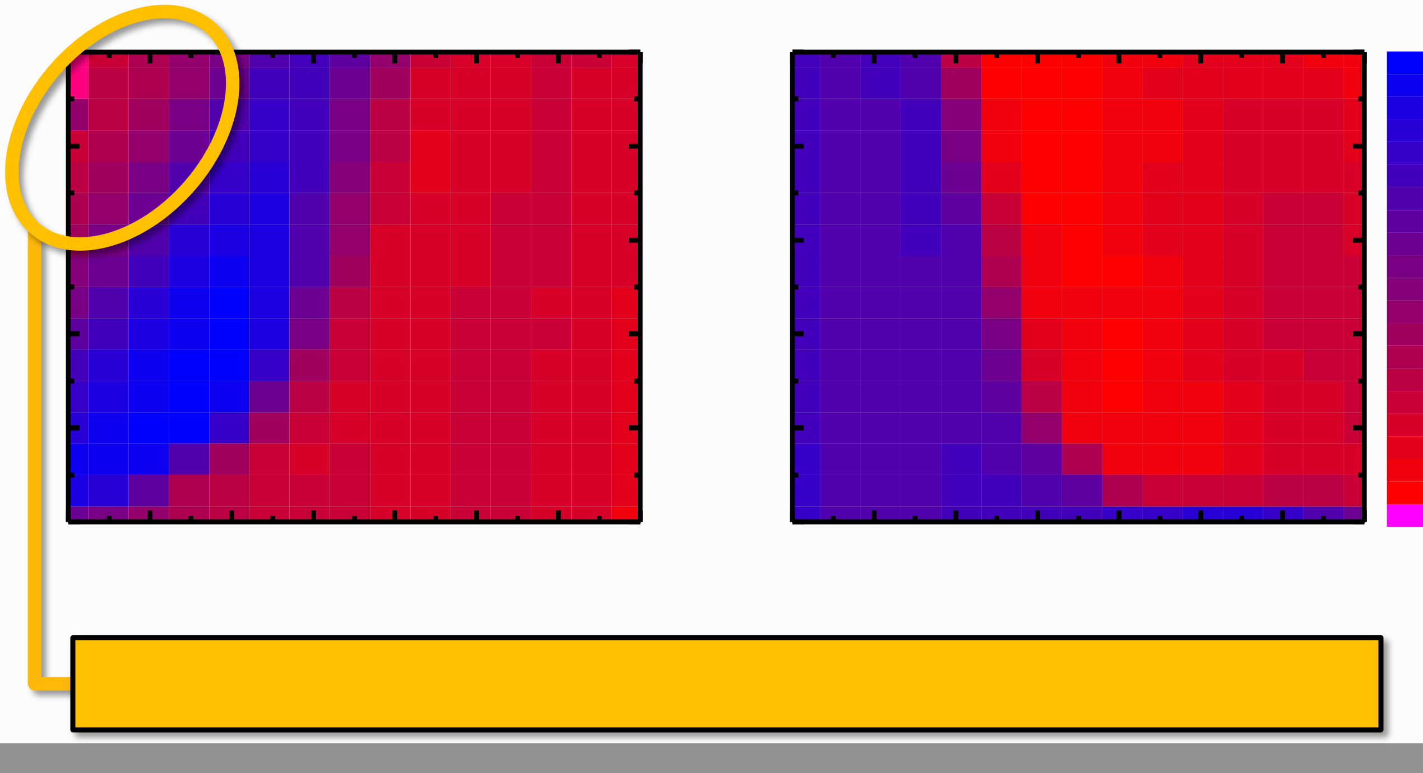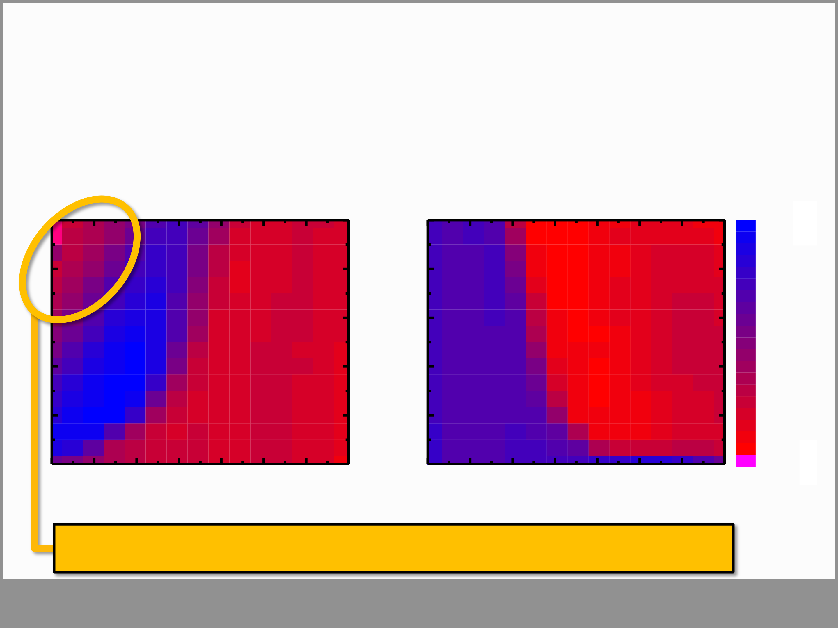

**Switching Speed and Voltage**   
• fast switching only limited by RC time < 100 ns   
• Both, **fe-switching & trapping** are **time & field** dependent

threshold voltage (V)

**charge injection degrades Memory Window**   
 **Slide 22**

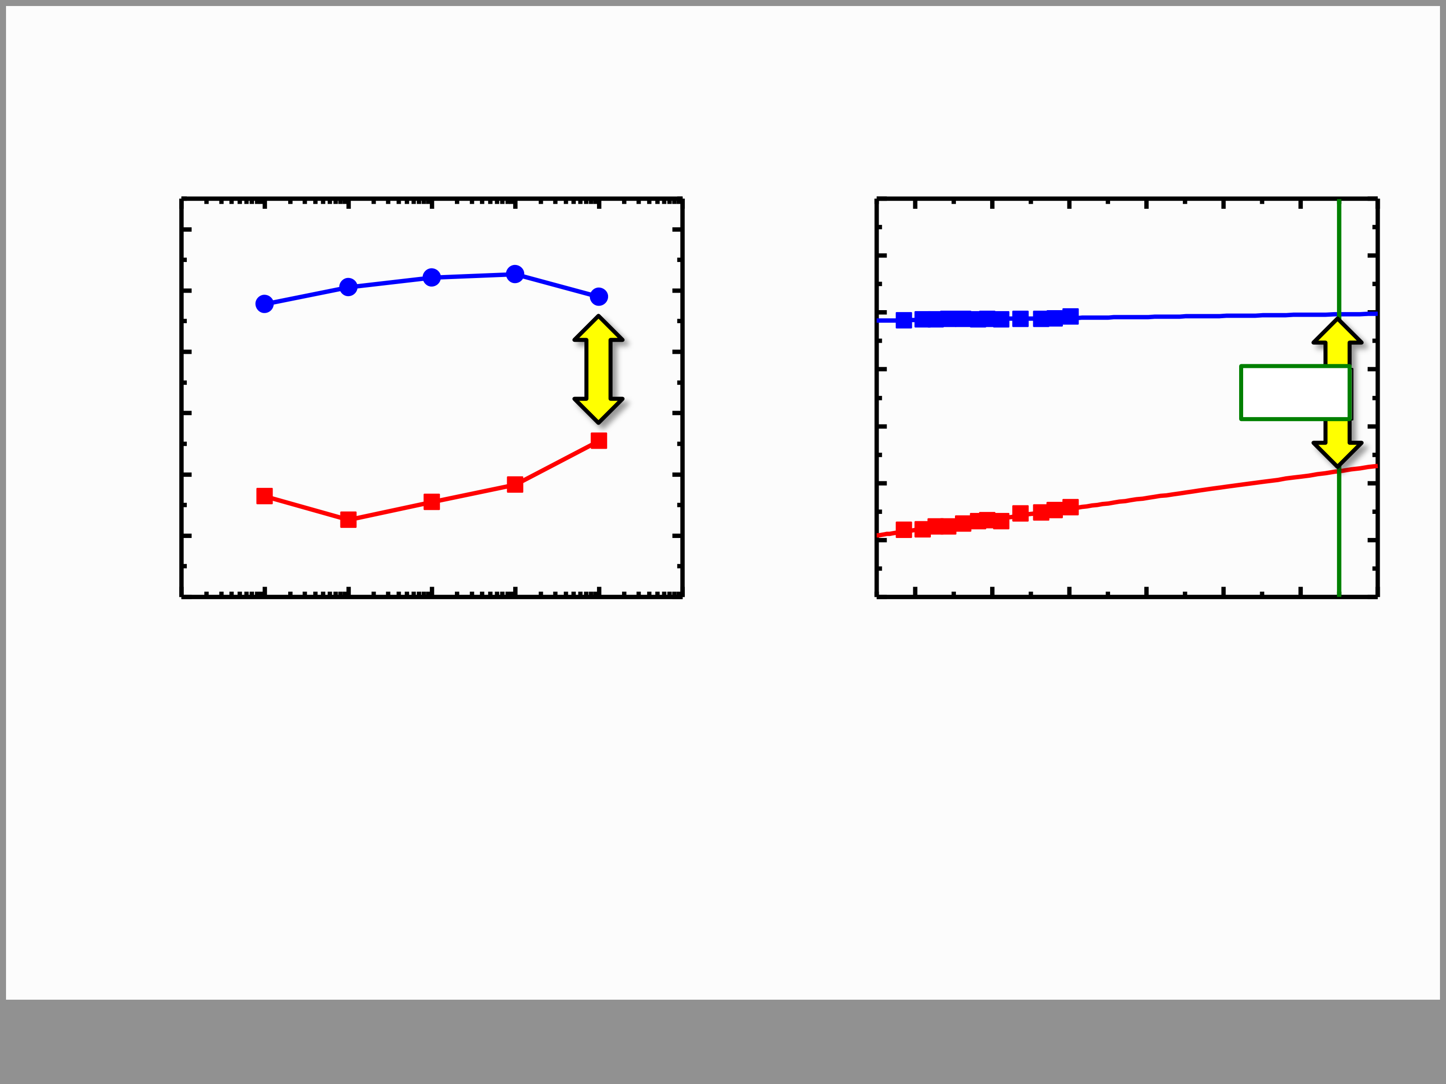

**Endurance & Retention**

|  |  |  |  |  |  |  |  |  |  |  |  |  |  |  |
| --- | --- | --- | --- | --- | --- | --- | --- | --- | --- | --- | --- | --- | --- | --- |
| **threshold voltage (V)** | 0.6 0.4 | PGM (100 ns -6V) | | 10 5 | **threshold voltage (V)** | 0.8 | PGM (100 ns -6V) | | | | | | | 9 |
| 0.6 |
| 0.4 |
| 0.2 | **residual MW** | | **residual MW** | | | | | **10y** | |
| 0.2 |
| 0.0 | **0.5 V** | |
| 0.0 |
| **0.6 V** | | | | | | |
| -0.2 | | | -0.2 |
| -0.4 ERS (100 ns 4V)  -0.6  10-1 10 0 10 1 10 2 10 3 | | 10 4 | -0.4 | ERS (100 ns 4V) | | | | | | |
| -0.6 |
| 3 | 4 | 5 | 6 | 7 | | 8 |
| **log time (s)** | | | | | | |
| **endurance cycles** | | |

• endurance limited to 104 cycles → extremly high E-fields • low retention loss observed → beneficial voltage divider • linear extrapolation: 10y data retention expected

**Slide 23**

|  |  |
| --- | --- |
| **Yield on 1st Silicon Memory Window**  **300 mm map**  **MW**  • all devices fully functional on 1st silicon  • ALD chamber geometry related MW-distribution   |  | | --- | | **Slide 24** | |

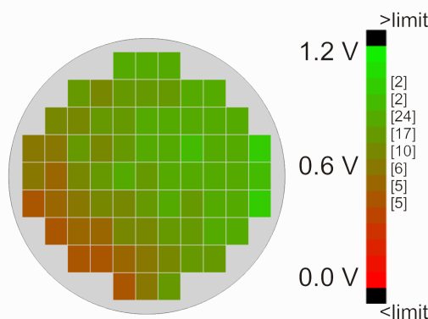

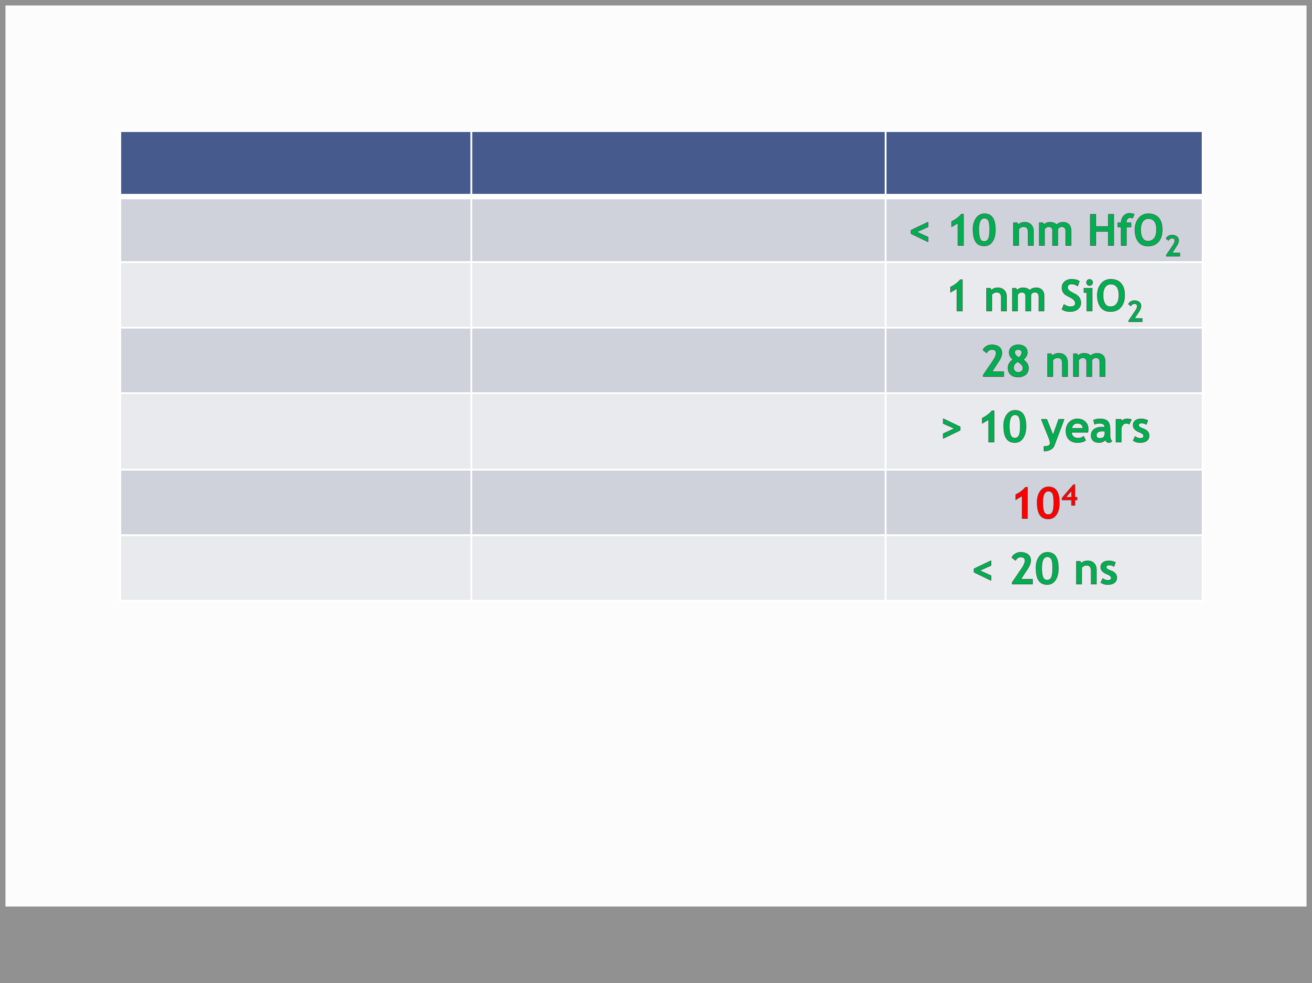

**Comparison with Contenders**

|  |  |  |
| --- | --- | --- |
| ferroelectric | **state of the art [1]** | **this work** |
| 200 nm SBT |
| interface | 7 nm HAO |
| gate length | 260 nm |
| retention | > 10 years |
| endurance | **109** |
| switching speed | > 1µs |

*[1] Hai, L.V. et al., IEEE IMW (2011)*

• the FeFET regained its scaling potential   
• endurance needs improvement → currently limited to applications with low endurance requirements

**Slide 25**

|  |  |
| --- | --- |
| **Outline**  • Introduction & Motivation  • Ferroelectricity in HfO2  • Adding nonvolatility to a 28 nm HKMG (FeFET) • FeFET Device Performance  • **Summary**   |  | | --- | | **Slide 26** | |

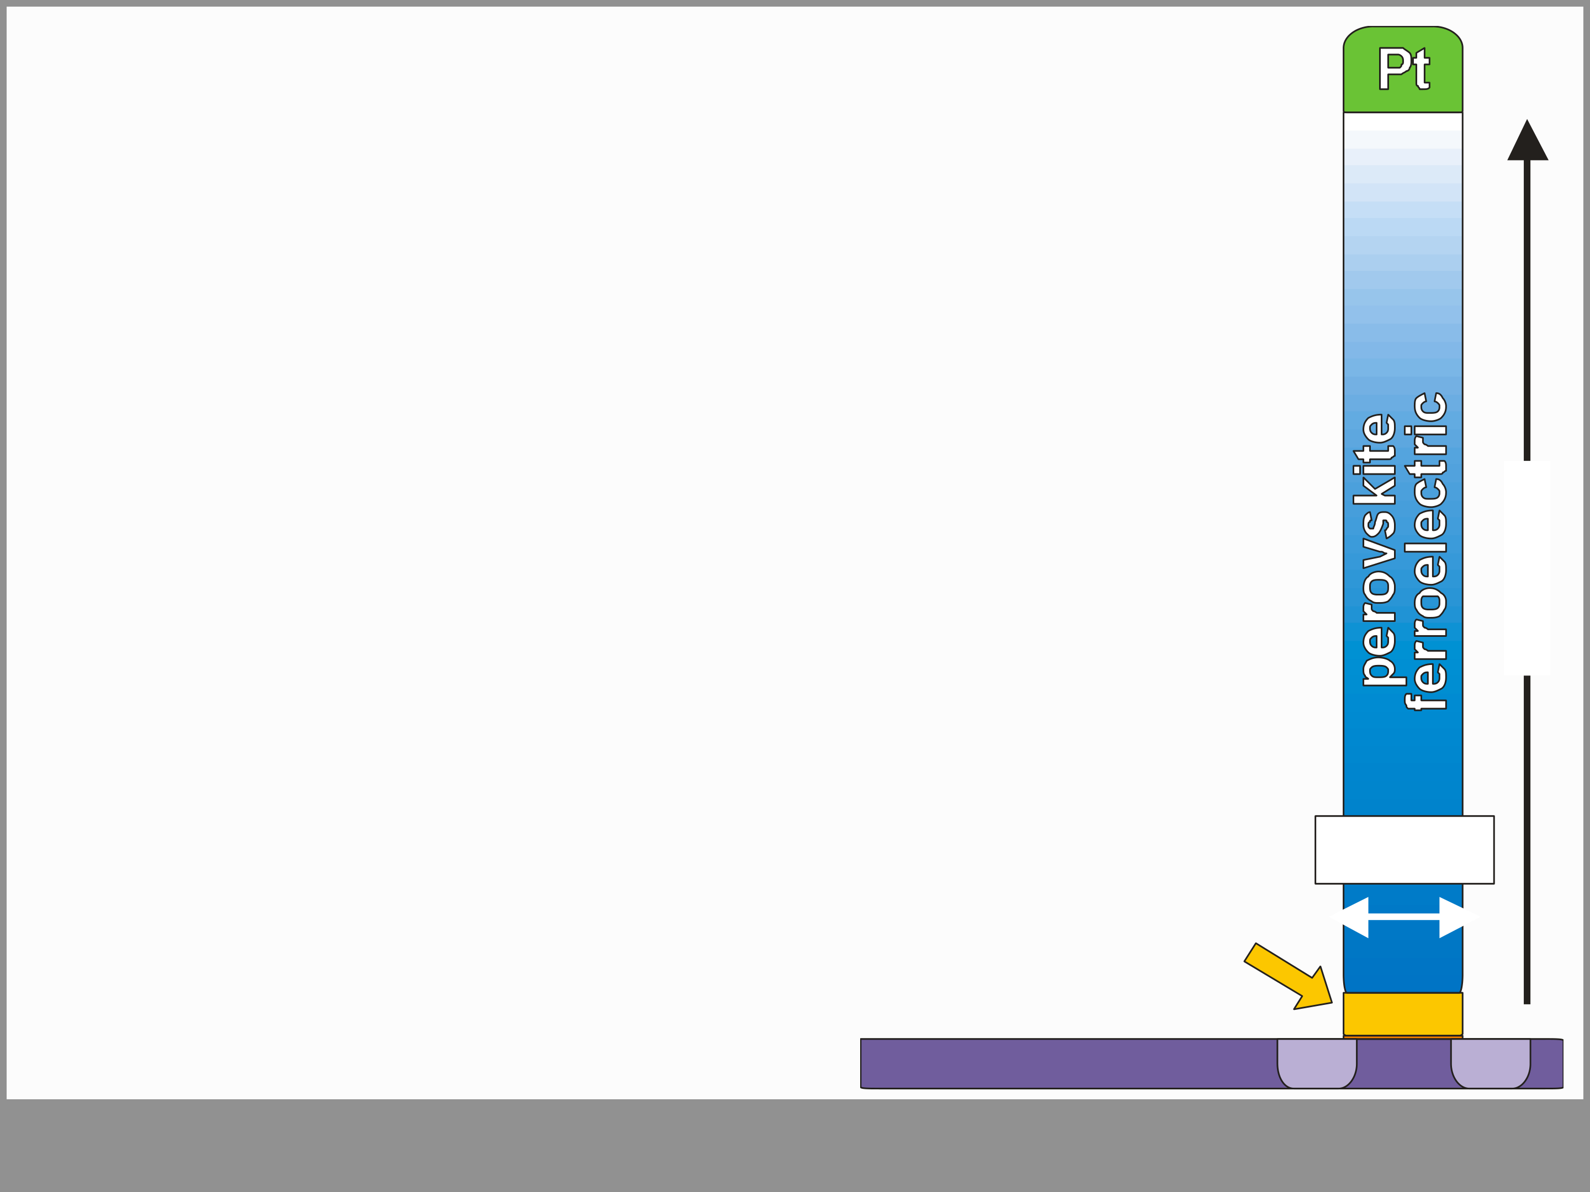

**Summary**

|  |  |
| --- | --- |
| … buffer layer becomes functionalized | **200 nm** |

**Slide 27**

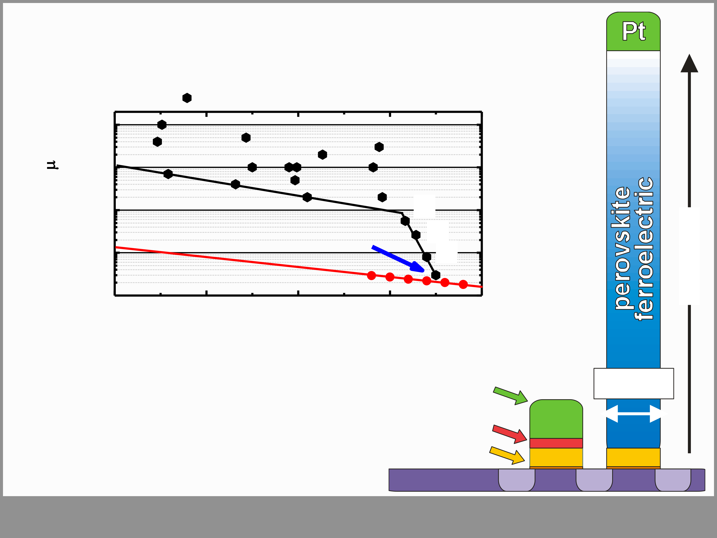

**Summary**  reported FeFETs in literature 10 2

|  |  |  |  |  |  |
| --- | --- | --- | --- | --- | --- |
| **gate length (****m)** | 10 1 | 2010 | [1] | 2015 | **200 nm** |
| 10 0 |
| [2]   [3] |
| 10-1 **this work**  10-2 **ITRS 2010: logic**  1995 2000 2005 |

**publication year**

|  |  |  |  |  |
| --- | --- | --- | --- | --- |
| *[1] Hai, L.V. et al., Semic. Sci. Technol.(2010)* | **poly-Si** | **n +** | **28 nm** | |
| *[2] Hai, L.V. et al., IEEE IMW(2011)* |
| *[3] Böscke, T.S. et al., IEEE IEDM(2011)* | **TiN gate fe-HfO2** |
| **n +** | **n +** |

**Slide 28**

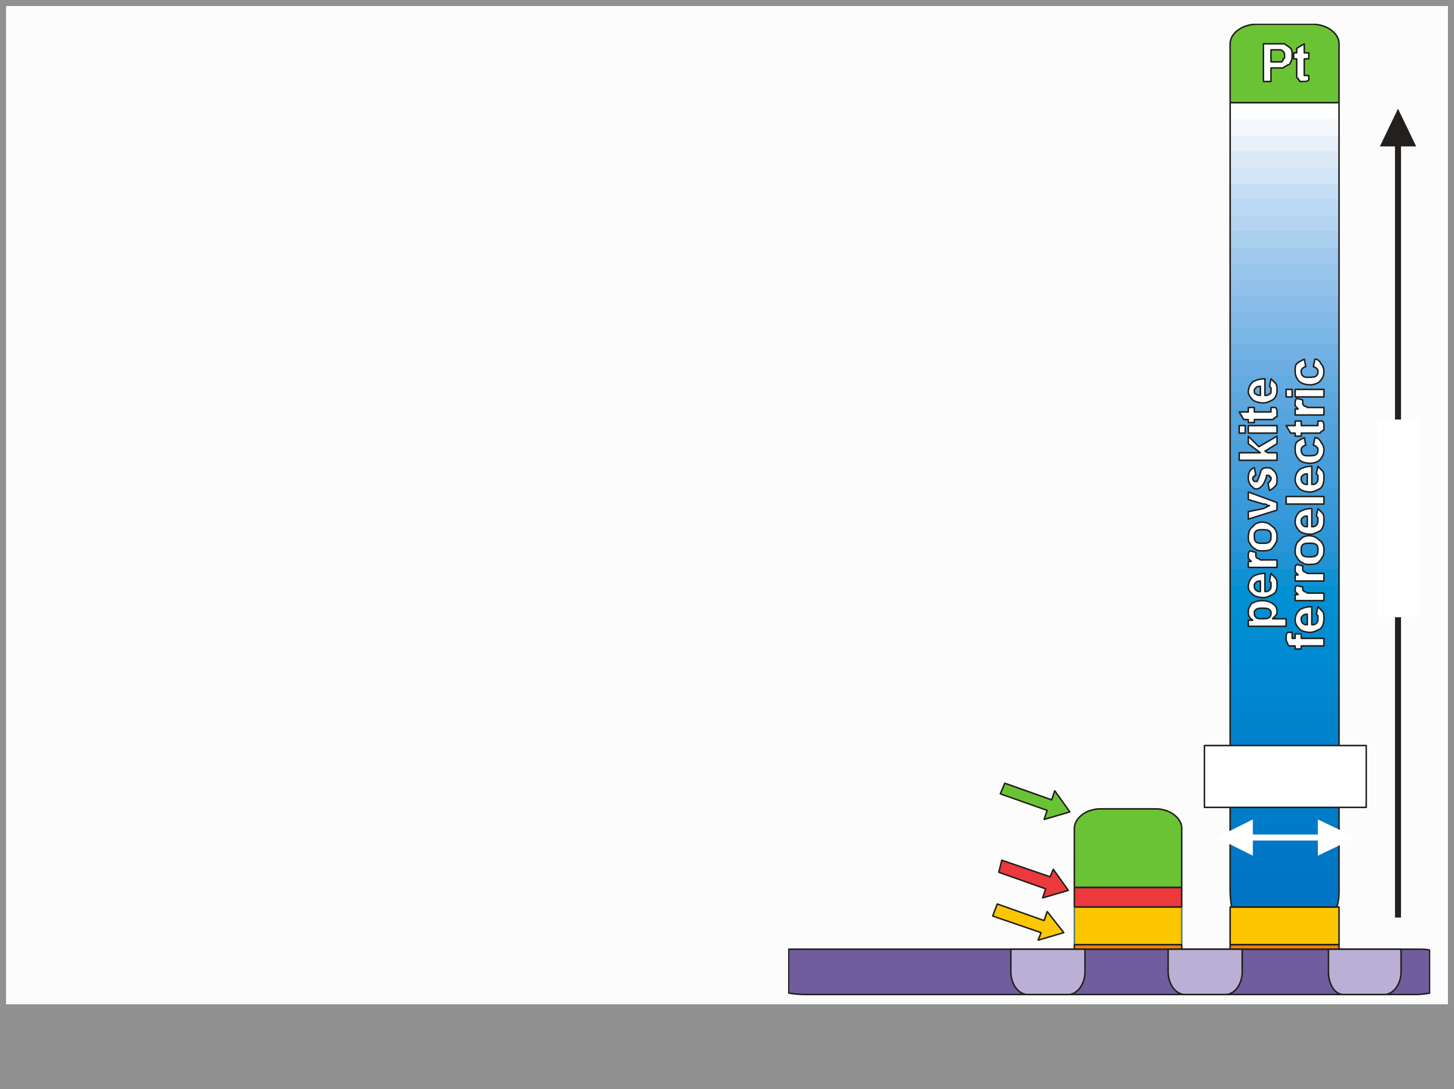

**Summary**

• highly scaled & fully CMOS compatible FeFET • nanosecond fast switching speed   
• promising retention (beneficial stack design)

|  |  |
| --- | --- |
| • endurance at lower flash specs (1st result) →**technology can directly benefit from** | **200 nm** |

**advances made in conventional HKMG**

**Slide 29**

|  |  |
| --- | --- |
| **THANK YOU !**  **Acknowledgments**  **FeFET-Team (Namlab & Fraunhofer CNT)**  **GLOBALFOUNDRIES (FAB1 Dresden)**   |  | | --- | | **Slide 30** | |

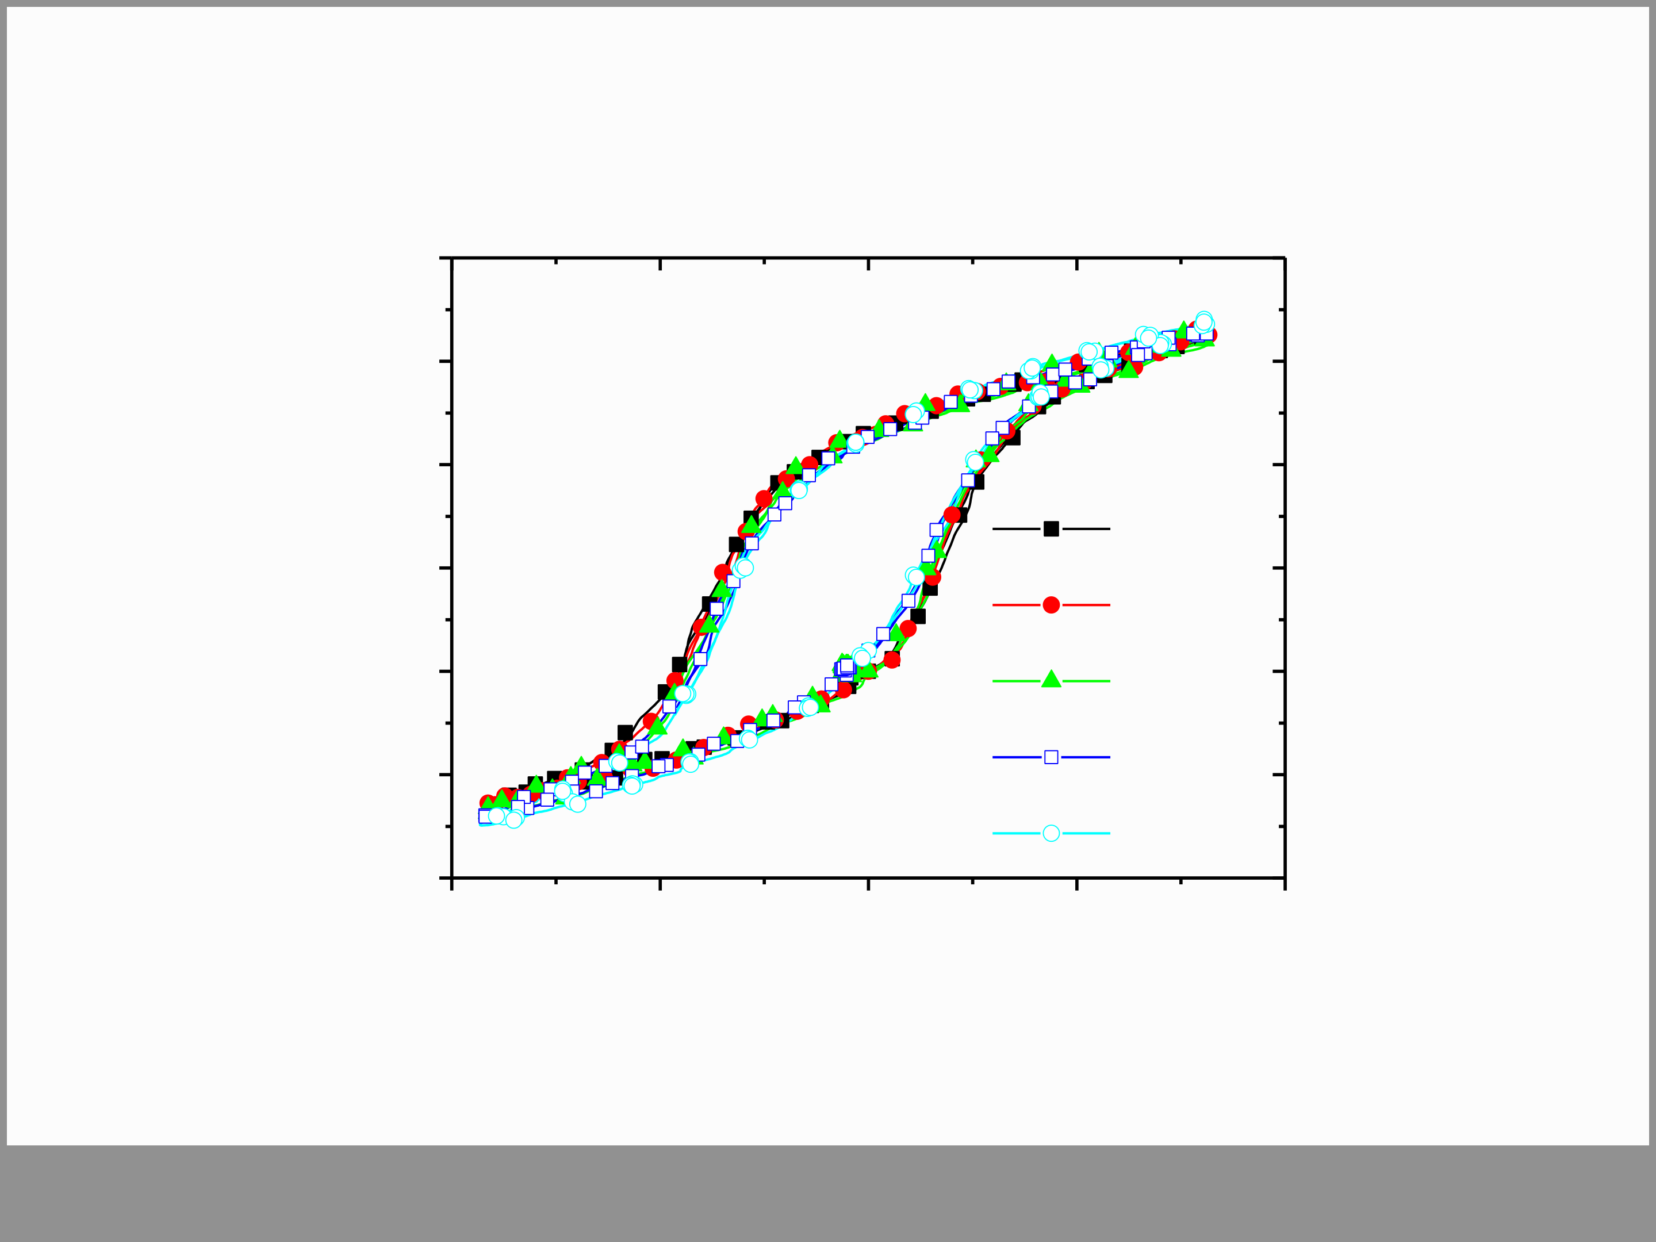

**Additional Information**  **- Thermal Stability -** 30

|  |  |  |  |  |  |
| --- | --- | --- | --- | --- | --- |
| 2) | 20 | 25 | oC | | 4 |
| Polarization (C/cm |
| 10 |
| 0 |
| 45 | oC | |
| -10 |
| 90 | oC | |
| -20 | 130 | | oC |
| 170 oC | | |
| -30  -4 |
| -2 0 2  Electric field strength (MV/cm) | | |

Yurchuck, E. et al., IMW 2012

**Slide 31**

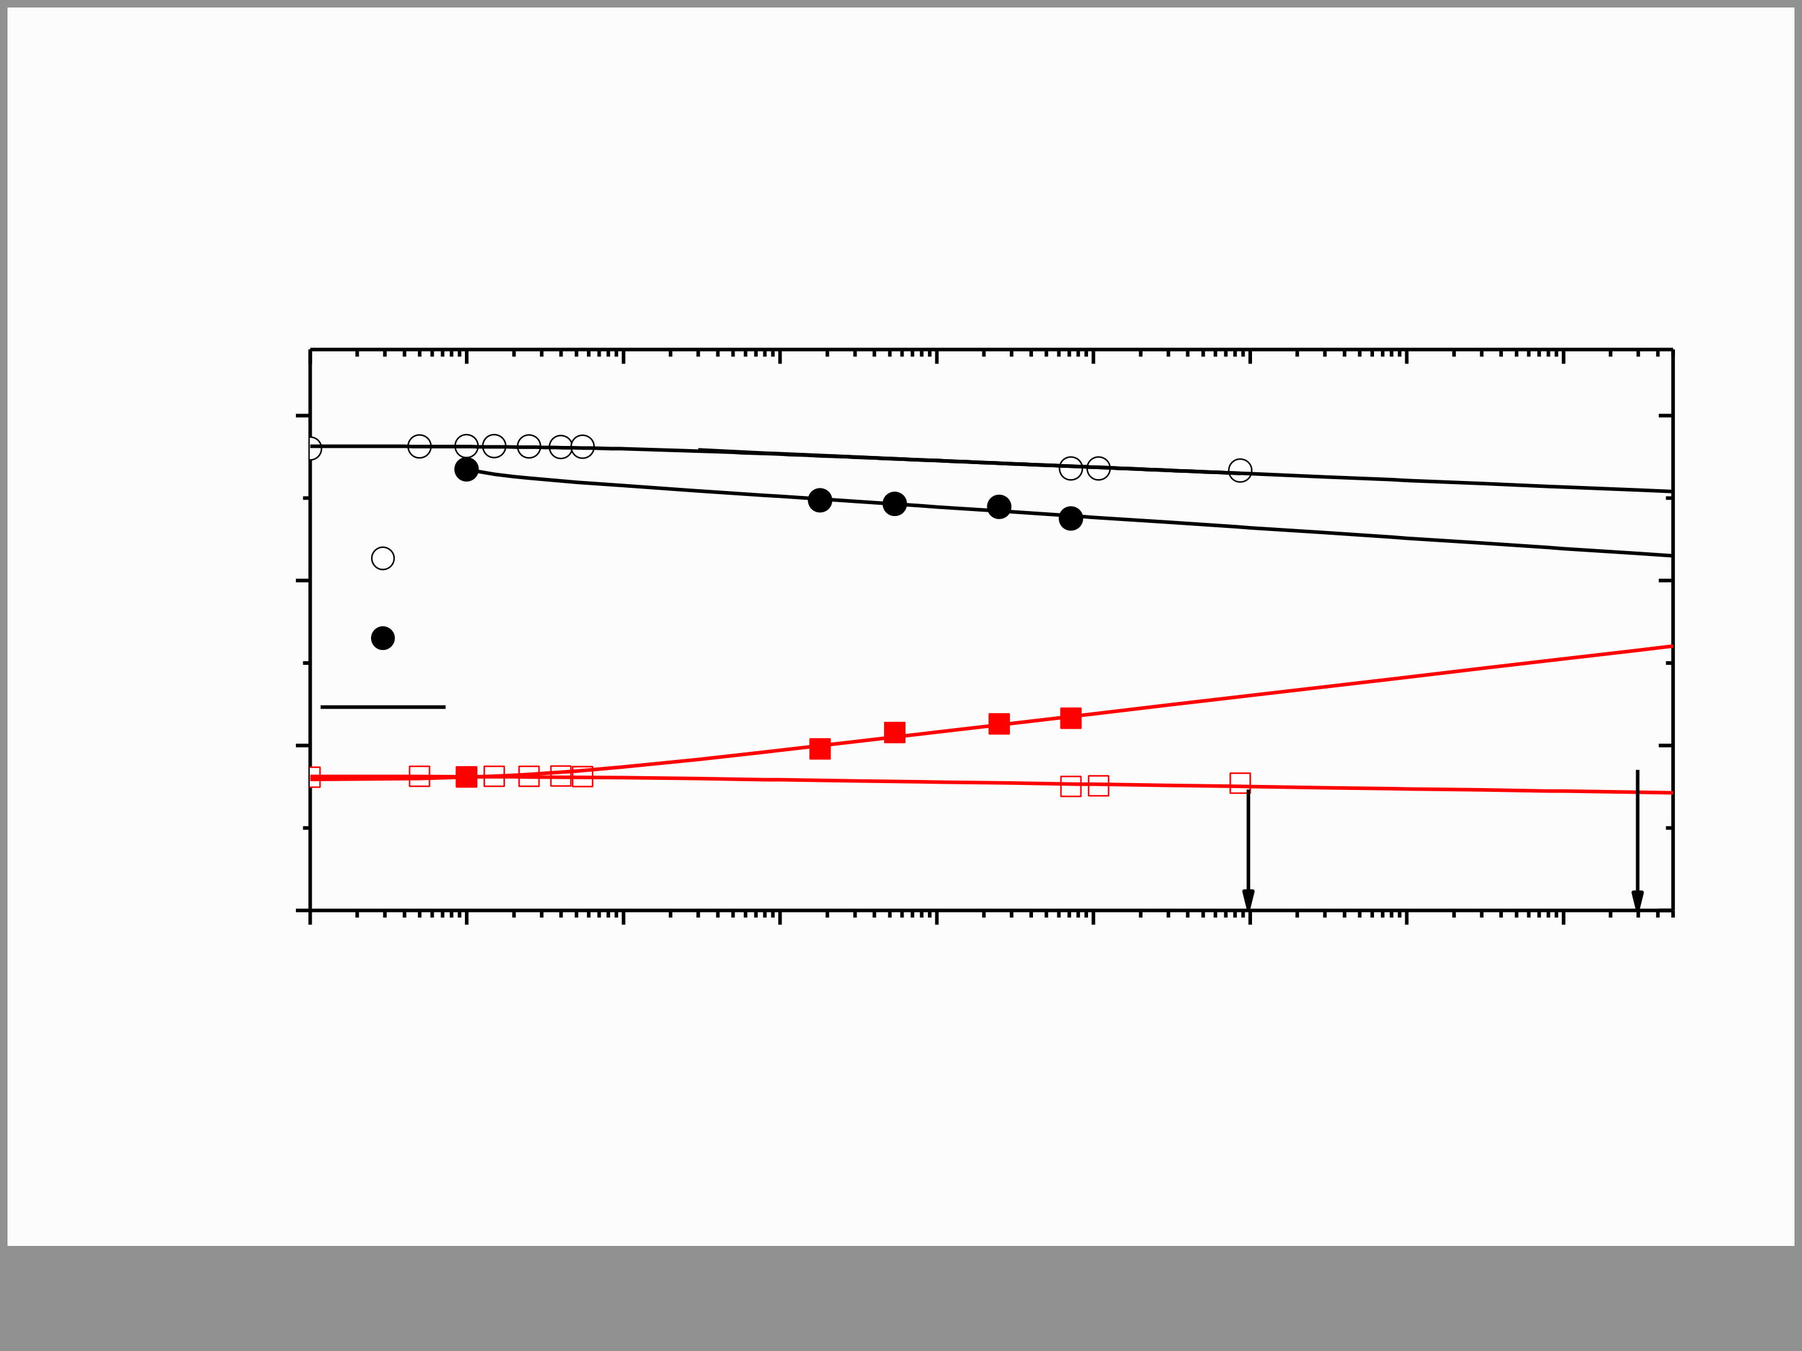

**Additional Information**   
**- T-Acceleration Retention -**

|  |  |  |  |  |  |  |  |  |  |
| --- | --- | --- | --- | --- | --- | --- | --- | --- | --- |
| Threshold voltage (V) | 1.0 | programmed -6.5 V 100 ns | | | 5 | 10 days | 10 | 7 | 10 years |
| 0.5 | Experimental data 25 oC  Experimental data 150 oC | | |
| 0.0 | Extrapolation | | |
| erased +4.5 V 100 ns  -0.5  10 0 10 1 10 2 10 3 | | 10 4 | 10 |
| 10 6 | 10 8 |
| time (s) | | | |

Yurchuck, E. et al., IMW 2012

**Slide 32**

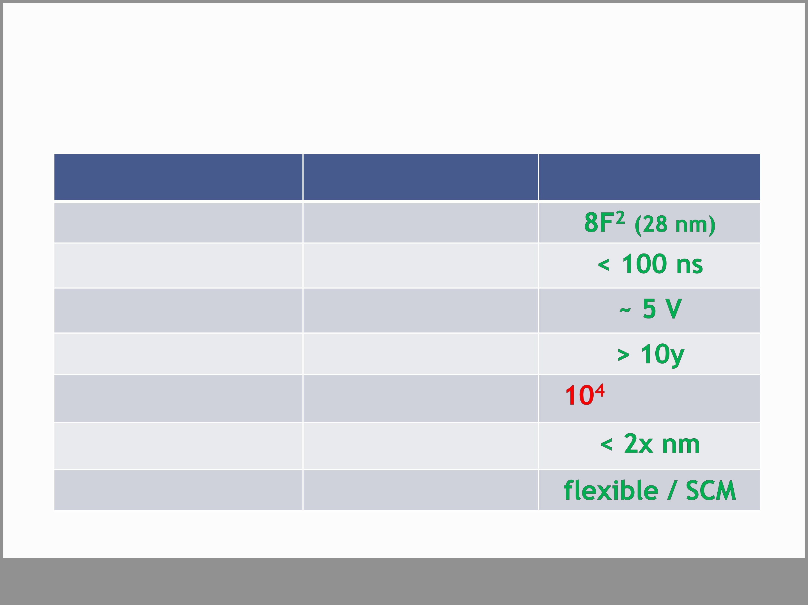

**Additional Information**   
**- NOR-FLASH Contender -**

|  |  |  |
| --- | --- | --- |
| cell area | **NOR-FLASH** | **AND-FeFET** |
| 10F2 (>100 nm) |
| speed (PGM/ERS) | 1 µs / 1ms | (1st result) |
| voltage (PGM/ERS) | 10 – 20 V |
| retention | >> 10y |
| endurance | **105** |
| scalability | << 100 nm ??? |
| storage type | code storage |

**Slide 33**